- Monthly Newsletter  December 2022  Important Dates:  POC Water Board Meetings are held on the third Thursday of each month @ 1pm  December 15 * January 19  Roll off Trash Bin  First Saturday of each month behind the POCID Office from 8am -2pm or UNTIL FULL  December 3rd * January 7th  Billing  Bills are mailed by the 1st  of each month and are due  on 20th of every month  and a late fee will be assessed  on the 21st unless that falls  on a weekend and then it  will be due the following  Monday.  Payment Methods:  Credit Card*Mail*Automatic  Bank Draft*Automatic Credit Card Draft*In Person*Payment Drop  Box* Bill Pay through your  Financial Institute  - Contact Us  POCID  39 Denman DR  PO Box 375  Port O’Connor, Texas 77982  361-983-2652  pocid@pocid.org  https://www.pocid.org/  https://www.facebook.com/POCIDofficial/  Vision Statement  POCID is a proactive organization making a positive impact on the community while implementing best management practices to promote sustainable success.  Mission Statement  To proactively and efficiently  manage the affairs of the District  for the benefit of its customers,  protect the health of the community, produce safe drinking water in adequate quantities, offer  competitive rates, assure  financial stability, and practice excellence in customer service. | “POCID”  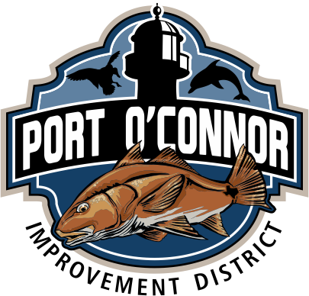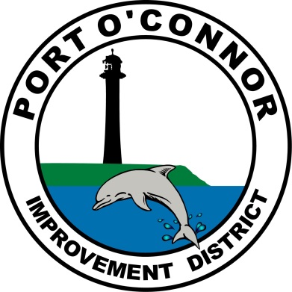  Year in Review  The year 2022 was a very busy and eventful year for POCID. The updated District logo the Board approved at the December 2021 meeting began to appear on District websites, letterheads, and facilities. In January, the District finished the formal consolidation procedures with LaSalle WCID No. 1A adding 1,159.8 acres to the District which increased the District boundaries from approximately 2,000 acres to 3,159.8 acres. After the completion of the District’s first ever property annexation in September of 2022, the total amount of acreage in the District increased to 3,269.588 acres.  In May, the six million in bonds from the Texas Water Development Board was released and work commenced on the projects contemplated in that bond issuance. These funds will be utilized to partially fund a new water well field and advanced water treatment system including reverse osmosis filtration. Also in May, the voters approved a 40-million-dollar bond and matching refunding bond authorization to be utilized for completion of the water treatment system along with expansion of the sewer vacuum collection system and other immediate and anticipated future needs of the District.  In November, the District received drill permits and production permits from the Calhoun County Groundwater Conservation District to commence work on the well field that is the anticipated future water source for the District. Also in November, bids were solicited for the long-awaited improvements involving the expansion of the district’s vacuum stations. The District anticipates construction will begin on Vacuum Station 1 expansion in January 2023 with Vacuum Station 2 to follow by March 2023.  .  Other notable construction projects included, an additional 7,800 feet in water lines, 7,400 feet in wastewater collection lines, and related valves and fire hydrants. Rehabilitation of the elevated storage tank and the groundwater storage tank was also completed in 2022  Not only did the district’s footprint grow during the course of the year, but the number of connections continued to climb. During 2022, there were an additional 75 water connections and 73 wastewater connections. This new growth also led to an increase in sales tax revenue, which through November produced $355,672.81 in income exceeding the 2022 total revenue of $348,892.70. In 2021, the sales tax revenue produced through November was $320,756.19. Anticipated additional property tax revenue generated by growth allowed the Board of Directors to decrease the district wide tax rate from $0.519 per $100 of assessed valuation to $0.509 per $100 of assessed valuation.  These increases in growth resulted in the need for additional space and upgraded technological capabilities so the District’s new office building was built—primarily funded by the funds LaSalle WCID No. 1A brought into the District after consolidation. It was completed in August of 2022 and an open house was held in September for all district customers to usher in the new space.  While 2022 was extraordinarily eventful, 2023 will also be very busy and a time of great growth and change as the District moves towards more water independence with the contemplated well fields and reverse osmosis system. There are additional projects in progress for further additions and improvements to District facilities to better serve the District’s customers.  The District’s employees would like to thank everyone for their continued support and cooperation as they try to increase operating efficiency and improve, along with operations, the District facilities to better serve District customers. The District employees, along with the Board of Directors, would like to wish all of you a very happy holiday season.
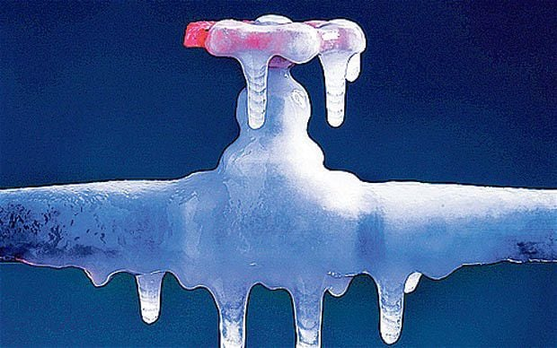
Protect your Pipes
As we approach the colder months of the year, we want to remind our customers what the cold can do to your exposed water lines. Pipes are at risk of freezing when temperatures drop below 32 degrees Fahrenheit, but they most commonly freeze at temperatures of 20 degrees and below. (Keep in mind, wind chill increases the risk of freezing.)

Pipes are most likely to burst when exposed to below-freezing conditions for six hours or more, which can happen throughout winter and early spring. Pipes that freeze most frequently are pipes that are exposed to severe cold, like outdoor hose bibs, swimming pool supply lines, and water sprinkler lines. Also, water supply pipes in unheated interior areas like crawl spaces, attics, garages, or kitchen cabinets. Pipes that run against exterior walls that have little or no insulation also freeze. Not everyone that lives in Port O’ Connor is a full-time resident, so getting your house prepared for colder weather is very important. Draining your lines when you leave is a very effective solution to keep your pipes from freezing. Water will still sit in your water heater but please make sure your water heater breaker is turned off. If anyone does not know how to prepare for colder temperatures, you are more than welcome to call the office for guidance. However, in the event of severe cold weather or another potential freeze, the District will not turn the water off to the customers property to protect your pipes. During the freeze of 2021 we were very lucky to have many members of our community isolating broken lines. If any members of our community would like to be put on a list to assist the district in the event of another freeze like 2021 please call the office at 361-983-2652.

Auto Draft Fee Waived

Sign up for Auto Draft with your Bank Account for NO FEE!! Please note that if you use your Credit Card there is a 3.5% fee.

* Go to the website @ www.pocid.org - select Bill Payment and log in or set up an account and then select I want to set up auto pay.

* Go online to https://www.pocid.org/all-forms and select POCID ACH & Credit Card Form then fill out a form and email it to www.pocid@pocid.org

* Contact the Port O'Connor Improvement Office at 361-983-2652

Irrigation Permits
All sprinkler systems require a permit completed and turned in to the POCID Office before installation. After installation a backflow inspection is required.
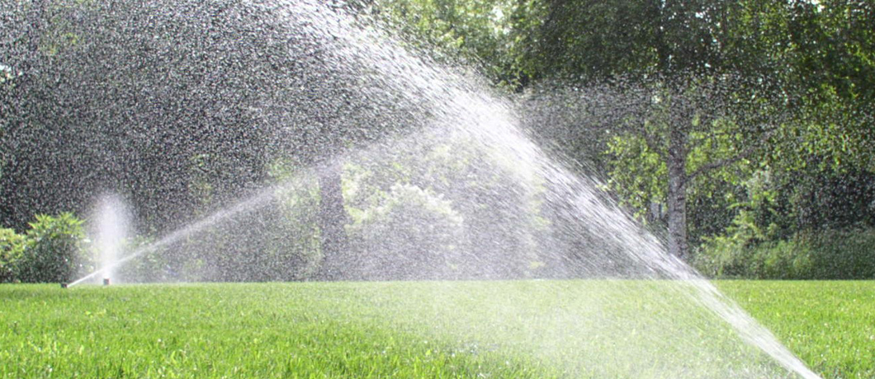
Check out our Website @ www.pocid.org
*Sign up for Alerts
* Pay your bill
* Applications/Forms
* Sign up for Auto Draft
* Current Projects
* Agendas/Minutes
* Updates
* Sign up for paperless billing

