- Monthly Newsletter  August 2022  Important Dates:  POC Water Board Meetings are held on the third Thursday of each month @ 1pm  September 15th * October 20th  Roll off Trash Bin  First Saturday of each month behind the POCID Office from 8am -2pm or UNTIL FULL  September 3rd * October 1st  Billing  Bills are mailed by the 1st  of each month and are due  on 20th of every month  and a late fee will be assessed  on the 21st unless that falls  on a weekend and then it  will be due the following  Monday.  Payment Methods:  Credit Card*Mail*Automatic  Bank Draft*Automatic Credit Card Draft*In Person*Payment Drop  Box* Bill Pay through your  Financial Institute  - Contact Us  POCID  39 Denman DR  PO Box 375  Port O’Connor, Texas 77982  361-983-2652  pocid@pocid.org  https://www.pocid.org/  https://www.facebook.com/POCIDofficial/  Vision Statement  POCID is a proactive organization making a positive impact on the community while implementing best management practices to promote sustainable success.  Mission Statement  To proactively and efficiently  manage the affairs of the District  for the benefit of its customers,  protect the health of the community, produce safe drinking water in adequate quantities, offer  competitive rates, assure  financial stability, and practice excellence in customer service. | “POCID”  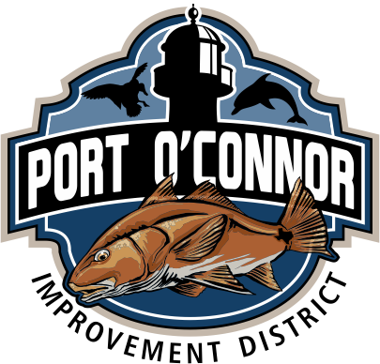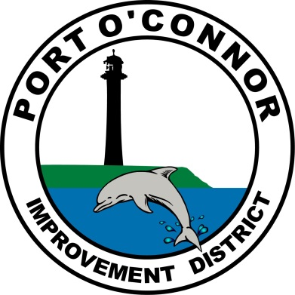  We Have Moved!  The new district office building is finished and all district functions, equipment, and personnel are now centered in the new building. When the old District office was purchased by the District from Steve Klein homes, it was supposed to be a “temporary” building to satisfy the immediate need for district offices. Then District President, Teddy Hawes, says the old building was a temporary office for a Steve Klein residential development. Teddy negotiated the terms to purchase the structure for the District and oversaw the movement and set up of the building so the District could better serve the public.  Temporary ended up being not so temporary as the building served as the District office for the next twenty plus years. A third-party inspection of the building revealed that to repair it would be very costly along with upgrading the wiring and features to utilize modern technology. After the cost estimates were received, the Board of Directors voted to build the new office building and sell the old one. The original building was declared as surplus property and was offered for sale through a bidding process. Forrest Hawes was the winning bidder.  The new office provides a lot more practical features to assist in the successful operation of the District. There are better areas for employees that double as components of the emergency plan (such as a shower for employees that get dirty in the field and that allows for overnight and prolonged days of occupancy in case of a natural disaster or other emergencies). The kitchen—that doubles as a training room—enables employees to remain in the office over the lunch hour and provides a space for ongoing employee training. The kitchen area can also be opened by a folding dividing wall to enlarge the main board meeting room for more space if needed for larger public meetings. This adaptable space also allows for overnight sleeping with the addition of portable cots during emergencies and provides a means to furnish meals during these times.  This increased space and its flexibility add valuable components and capabilities to the District's Emergency Operations Plan.  Technology has been upgraded to support modern equipment and capabilities—both in the office and out in the field—to increase the efficiency and reliability of operations. Technology in the board room allows for increased meeting flexibility and the new board podium allows for all directors to face the public at all times.  The building also features increased storage for maps, a room for official district records, and storage for equipment. Drive through service for customers is also now available.  District personnel appreciates everyone’s patience during the move and transition into the new building as office procedures and operations were delayed or altered during those weeks of moving and reorganizing.  The Board of Directors welcomes the public to an open house on September 17, 2022 from 11am to 1pm to tour the new building.  Ongoing Improvements  In an effort to continue to improve the sewer services during heavy rainfall events, in an effort to continue to improve the sewer services during heavy rainfall events, the District is in the process of replacing some of our old one piece buffer tanks. These old buffer tanks are actually just a manhole with dual vacuum pumps to adapt them to our vacuum sewer systems. They are made of concrete and often-times let rain water into the tank depending on age and condition.  The new buffer tanks are similar to the smaller pits in construction. They are constructed of fiberglass and are dual chambered so that the sewer goes into the bottom chamber which is sealed from the upper chamber where the controls are. This configuration will allow District personnel to maintain and repair the controls and pump in a safer and more timely manner.  The District has been working with Lester Construction on the buffer tank that services the American Inn and St Christophers. Next on the list is the one on Maple serving Alligator Head.  The buffer tank at the school & Coast Guard Station will be eliminated and replaced with a pit that will better serve the District.  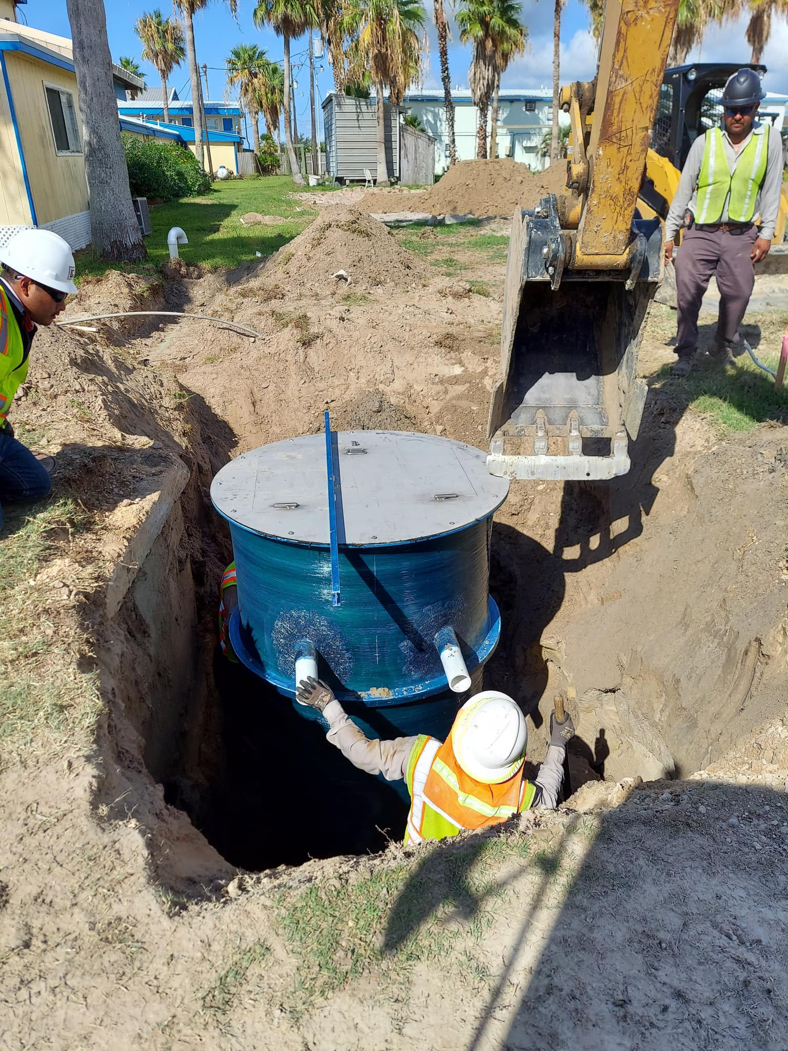

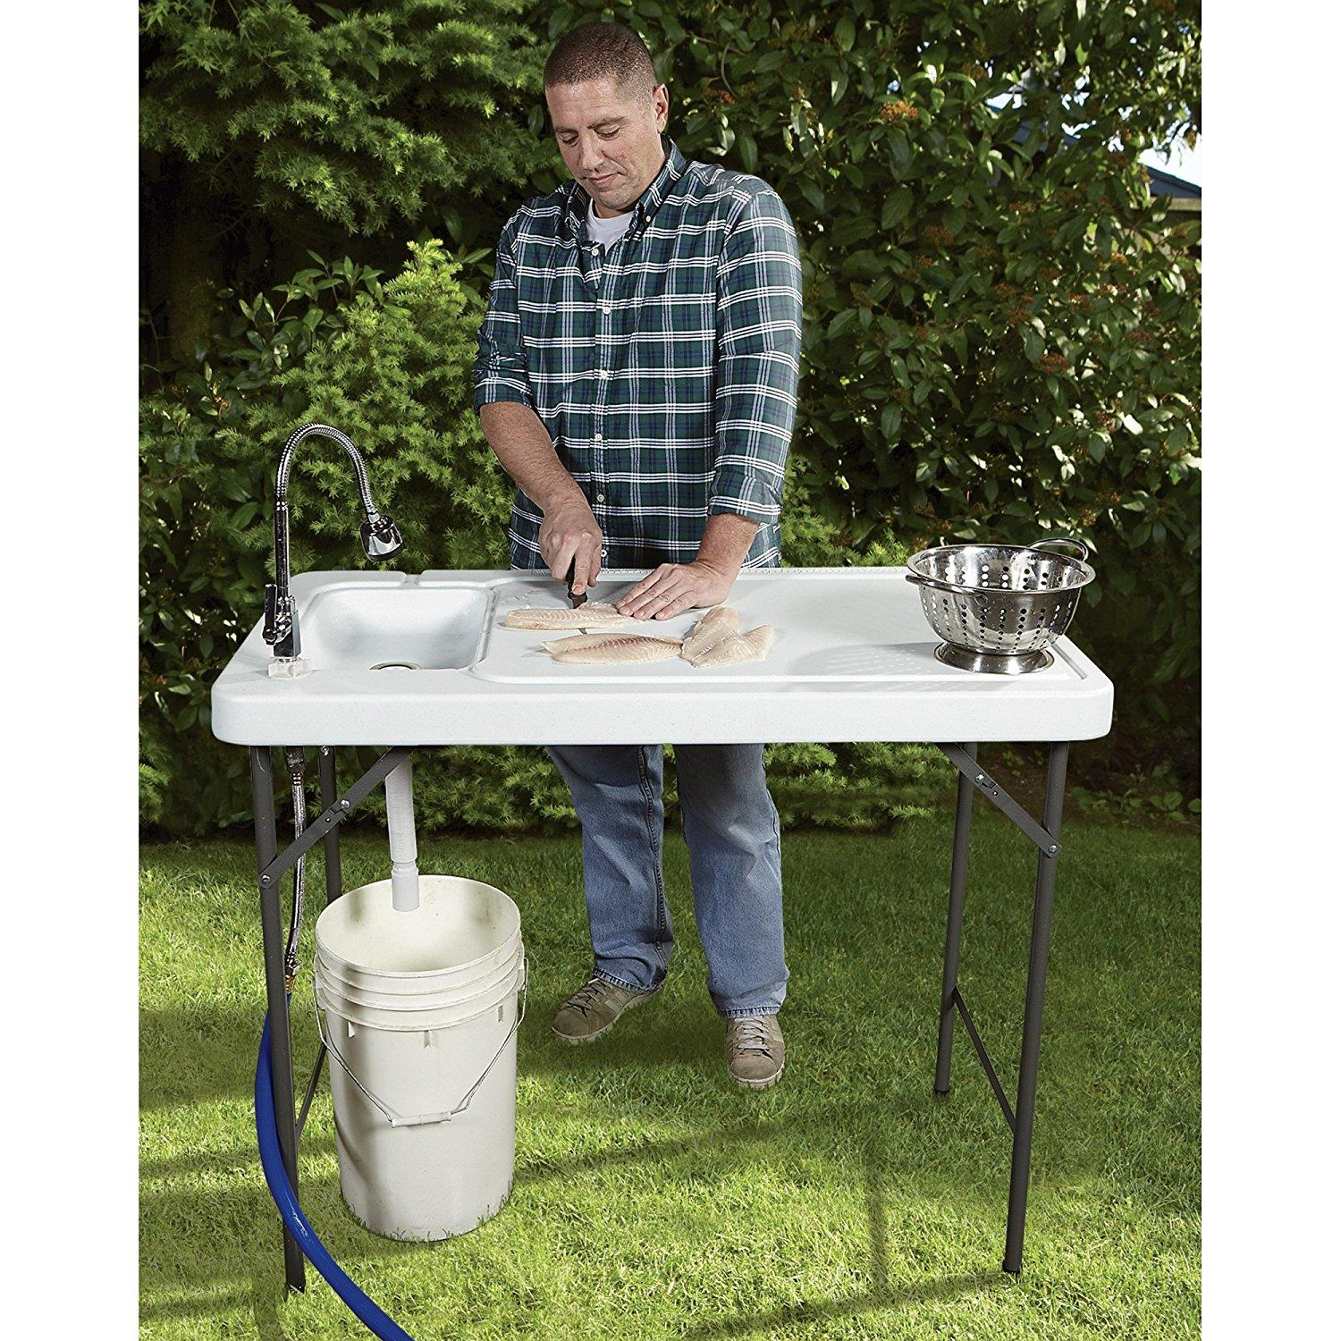
ALL Outdoor Showers and fish cleaning stations need a permit & an inspection per District Policy. We are actively identifying these to insure we do not have an excess of rainwater in our sewer system. The smoke testing did help us with these. Please
call the
District office @
361-983-2652 to obtain the required permit.

If you are closing your account, you must call the office and do so. You will continue to receive a bill until it is closed.
The buyer cannot close your account.
Auto Draft Fee Waived

Those of you who have been utilizing the ACH payment option, there is NO CHANGES NEEDED ON YOUR PART and you will see, on your next statement, that the fee has been removed. If any of our customers would like to start using this payment option:
* Go to the website @ www.pocid.org - select Bill Payment and log in or set up an account and then select I want to set up auto pay.
* Go online to https://www.pocid.org/all-forms and select POCID ACH & Credit Card Form then fill out a form and email it to www.pocid@pocid.org
* Contact the Port O'Connor Improvement Office at 361-983-2652
Irrigation Permits
All sprinkler systems require a permit completed and turned in to the POCID Office before installation. After installation a backflow inspection is required.
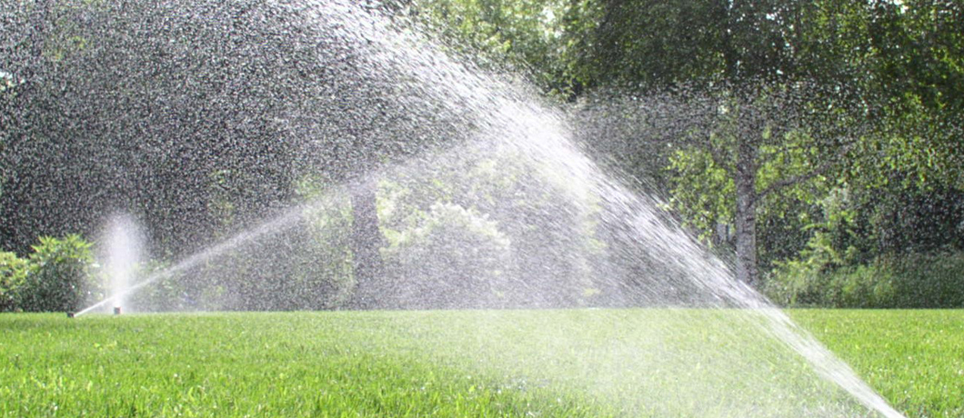
Check out our Website @ www.pocid.org
*Sign up for Alerts
* Pay your bill
* Applications/Forms
* Sign up for Auto Draft
* Current Projects
* Agendas/Minutes
* Updates
* Sign up for paperless billing

