|  |  |  |  |  |
| --- | --- | --- | --- | --- |
| |  | | --- | | Monthly Newsletter  August 2023 | | |  | | --- | | Important Dates:  **POC Water Board Meetings are held on the third Thursday of each month @ 1pm**    *August 17th *  September 21st*  **Roll off Trash Bin**  **First Saturday of each month behind the POCID Office from 8am -2pm or UNTIL FULL**  *August 5th * September 2nd* | |   **Billing**  ***Bills are mailed by the 1st***  ***of each month and are due***  ***on 20th of every month***  ***and a late fee will be assessed***  ***on the 21st unless that falls***  ***on a weekend and then it***  ***will be due the following***  ***Monday.***  **Payment Methods:**  *Credit Card*Mail*Automatic*  *Bank Draft*Automatic Credit Card Draft*In Person*Payment Drop*  *Box* Bill Pay through your*  *Financial Institute*  Contact Us  POCID  39 Denman DR  PO Box 375  Port O’Connor, Texas 77982  361-983-2652  pocid@pocid.org  <https://www.pocid.org/>  <https://www.facebook.com/POCIDofficial/>  **Vision Statement**  *POCID is a proactive organization making a positive impact on the community while implementing best management practices to promote sustainable success.*  **Mission Statement**  *To proactively and efficiently*  *manage the affairs of the District*  *for the benefit of its customers,*  *protect the health of the community, produce safe drinking water in adequate quantities, offer*  *competitive rates, assure*  *financial stability, and practice excellence in customer service.* | **“POCID”**      **POC Improvement District Water System Awarded a Superior Rating**  There are new signs as you enter Port O’Connor that read: “Superior Public Water System.” This designation is awarded by the Texas Commission on Environmental Quality. The United States Environmental Protection Agency (“EPA”) provides the TCEQ with authority to administer the Public Drinking Water program in Texas.  To achieve this “Superior Public Water System” designation the District has to exceed certain standards that are outlined in the Texas Administrative Code. Even though one of the most important factor to consumers is water quality, the standards required to earn this recognition involve more than just the quality of the drinking water. In general, the factors also include adequate oversight of the system, effective planning and preparedness, capacity requirements, and good housekeeping.  The following are additional requirements that must be met to attain recognition as a “Superior Public Water System:”  (a) The water system shall be well maintained and present a pleasing appearance to the public. While the general appearance does not affect the water quality, to achieve this superior designation systems are help to a higher standard.  (b) There must be a minimum of two licensed operators with additional operators required for larger systems. This ensures adequate staffing of the system to provide increased oversight.  (c) Under the Safe Drinking Water Act, the EPA sets national limits on contaminant levels in drinking water to make sure the water is safe for human consumption. To be awarded as a “Superior Public Water System” a system must have gone 24 months without microbiological violations of these drinking water standards.  (d) The quality of the water shall comply with all primary water quality parameters listed in the drinking water standards.  (e) The chemical quality of the water shall comply with all secondary constituent levels listed in the drinking water standards.  (f) The system’s operation shall comply with applicable state statutes and minimum acceptable operating practices for public drinking water systems as set forth in the Texas Administrative Code.  (g) The system’s capacities shall meet or exceed minimum water system capacity requirements set forth in the Texas Administrative Code.  (h) Certain requirements that ensure the system can adequately provide for consumers, even in the event of an unforeseen situation, such as requiring that the system have at least two wells, two raw water pumps, or a combination of these with enough capacity to provide average daily consumption with the largest well or pump out of service. This requirement shall also apply to treatment plant pumps necessary for operation in accordance with the Texas Administrative Code.  (i) Physical facilities shall comply with the requirements in the Texas administrative Code including documenting, reporting, flushing, etc.  The Board of Directors thanks our District management team and District employees for ensuring the District facilities are maintained, applicable standards are met, proper testing and recording procedures are followed, and all they to do to ensure that the drinking water is safe for consumption by the District’s customers. The Board congratulates them on achieving this designation for the District’s public drinking water. |

**You now have the option to pay 24/7 by credit card by calling**

**844-923-2162.**

**We will accept Visa, MasterCard and Discover for a 3.5% service fee.**



**Irrigation Permits**

**All sprinkler systems require a permit completed and turned in to the POCID Office before installation. After installation a backflow inspection is required.**

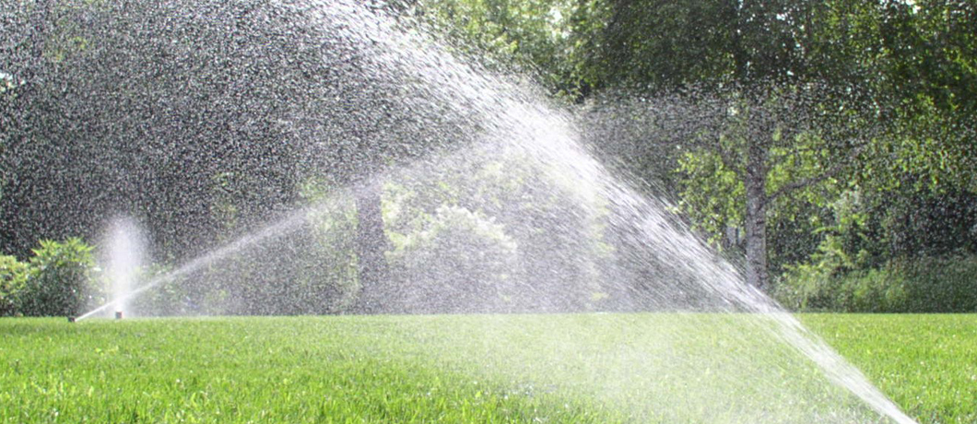

Check out our Website @ [www.pocid.org](http://www.pocid.org)

**\*Sign up for Alerts**

**\* Pay your bill**

**\* Applications/Forms**

**\* Sign up for Auto Draft**

**\* Current Projects**

**\* Agendas/Minutes**

**\* Updates**

**\* Sign up for paperless billing**

**POCID Rules and Regulations require all customers to have a customer service valve outside their meter box within 3 feet of the meter box.**

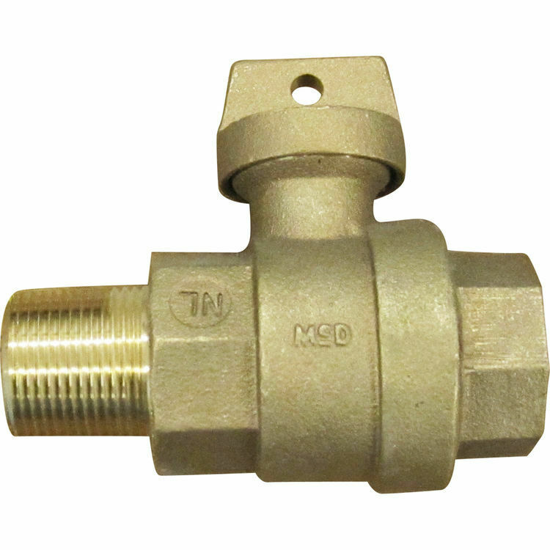



**Auto Draft Fee Waived**

Sign up for Auto Draft with your **Bank Account** for **NO FEE**!! **Please note that if you use your Credit Card there is a 3.5% fee.**

* Go to the website @ [www.pocid.org](https://l.facebook.com/l.php?u=http%3A%2F%2Fwww.pocid.org%2F%3Ffbclid%3DIwAR1RcLWgEPAebm-ZNp70EGMkdf6QCoy3I49g8QBfZVBynTieC7M20Sd3RQk&h=AT1Prcf9xoYbUFAOUcPOxbg7MUs3wGQteTOXAnPb0XsyQCf_6nsq8S0ZLhR6gLylSJ80jN-WzzwV6QRPV52KfYSAijxP7_rrHN-19yrmajQQWAYzCSAZEvriyvu3Vy86IA&__tn__=-UK-R&c%5b0%5d=AT0It4OKA8z8brbuTEnJqAzCMRBHMWLw_RM2miWdY3o9svX_12_RvDSSq26YlU-s4v5tTlpPMHOUpK6s8jjULL9C2sIy7JIpjBjH7NA7aYPhlrnfv6gpcwlxJ7UoVdNXPbOcIl0SqPXJ6ooseBqevuzRmBexfu8PNPwqE-P6XUSBxA) - select Bill Payment and log in or set up an account and then select I want to set up auto pay.

* Go online to [https://www.pocid.org/all-forms](https://www.pocid.org/all-forms?fbclid=IwAR0ESAVw63Q2_aWjDFNmgcVcvFVRqAQk7sO08dwwTp0zozGdy7qZCfYrRZc) and select POCID ACH & Credit Card Form then fill out a form and email it to [www.pocid@pocid.org](http://www.pocid@pocid.org)

* Call 844-923-2162 and pay your bill by phone 24/7

* Contact the Port O'Connor Improvement Office at 361-983-2652



