|  |  |  |  |  |
| --- | --- | --- | --- | --- |
| |  | | --- | | Monthly Newsletter  March 2023 | | |  | | --- | | Important Dates:  **POC Water Board Meetings are held on the third Thursday of each month @ 1pm**    *March 16th * April 20th*  **Roll off Trash Bin**  **First Saturday of each month behind the POCID Office from 8am -2pm or UNTIL FULL**  *March 4th * April 1st* | |   **Billing**  ***Bills are mailed by the 1st***  ***of each month and are due***  ***on 20th of every month***  ***and a late fee will be assessed***  ***on the 21st unless that falls***  ***on a weekend and then it***  ***will be due the following***  ***Monday.***  **Payment Methods:**  *Credit Card*Mail*Automatic*  *Bank Draft*Automatic Credit Card Draft*In Person*Payment Drop*  *Box* Bill Pay through your*  *Financial Institute*  Contact Us  POCID  39 Denman DR  PO Box 375  Port O’Connor, Texas 77982  361-983-2652  pocid@pocid.org  <https://www.pocid.org/>  <https://www.facebook.com/POCIDofficial/>  **Vision Statement**  *POCID is a proactive organization making a positive impact on the community while implementing best management practices to promote sustainable success.*  **Mission Statement**  *To proactively and efficiently*  *manage the affairs of the District*  *for the benefit of its customers,*  *protect the health of the community, produce safe drinking water in adequate quantities, offer*  *competitive rates, assure*  *financial stability, and practice excellence in customer service.* | **“POCID”**      **Future Water Supply Update**                  As many of you already know, the Board of Directors made a decision a couple of years ago to seek water independence.  This decision was made in light of the projections of the future GBRA plant expansion, revamp, or possible rebuild.  Several town hall meetings were conducted to discuss the issue and options with the public.  Since that time, the Board has been working with its consultants to develop that plan.  Numerous steps had to be taken such as:  the procurement of bonds to finance the wells, necessary RO system, and other components such as additional ground storage tanks; obtaining ground water permits from the Calhoun County Groundwater District; engineering design and TCEQ approval of all plans and specs; obtaining an easement and Corp of Engineer permits for the RO discharge line; easements from the county and other land owners for well placements; the purchase of property for additional well sites; environmental impact studies; and navigating the requirements imposed by the Texas Water Development Board. At times, it felt like this project would never come to fruition at any time in the near future due to all the issues that had to be navigated and all agency requirements and approvals, but the Board persevered.  In January, the Board approved contracts for the drilling of the wells.  This work should commence by March 15, 2023 and the wells are scheduled to be completed by April 30, 2024, barring any unforeseen delays due to weather or other issues beyond anyone’s control.                  Other components in the process include the Reverse Osmosis treatment system and related electrical controls, and water pipelines.  These will be going to construction over the next 3 months with all of the projects anticipated to be completed by May of 2024.                  Once these projects are constructed and tested, the system will be ready to be placed on line and the journey to more water independence will take a huge step forward.                  In the meantime, the District has contracts with Undine, the purchaser of the GBRA plant, and GBRA to continue a reliable water supply source.  RV Park Inspections  In order to continue to maintain the quality of Port O’ Connor Improvement District’s Sewer Vacuum System at the highest level possible, we will conduct yearly inspections of every RV park or every property that has 4 or more RV connections. To get the best possible performance out of the sewer system, it is very important that the system stay sealed to any outside elements.  Things that we will be looking for during the inspection are open, unsealed, or broken RV connections. All outdoor water faucets must have hose bib vacuum breakers. No sinks, showers, or fishing cleaning tables can be tied to our sewer without being enclosed. Also, pumping of rainwater from ditches, parking lots, etc. into the sewer collection system is prohibited.  We are constantly looking for ways to improve our sewer system and keep it free from any potential hazards. Our long-term goal is to continue to identify problems within our system and fix them accordingly, to provide the best possible service for our community.  Rv Park Illustrations, Royalty-Free Vector Graphics & Clip Art - iStock  Backflow Inspections  As required by TCEQ all back flow prevention devices must be installed by a Certified BPA Installer and must be inspected upon installation by a Certified BPA Inspector.  Furthermore, all Reduced Pressure Zone (RPZ) devices must be inspected annually to ensure they are still working properly and they still meet the need for which it was installed.  If you are installing a sprinkler you must get a permit from the POCID Office and the completed back flow inspection sheet filled out by the certified tester needs to be turned in to the office upon completion. Please make sure to get your certificate turned in to the District to ensure continued water service. |

**We will be closing for Lunch from 12PM to 1PM starting February 6, 2023.**



**Irrigation Permits**

**All sprinkler systems require a permit completed and turned in to the POCID Office before installation. After installation a backflow inspection is required.**



Check out our Website @ [www.pocid.org](http://www.pocid.org)

**\*Sign up for Alerts**

**\* Pay your bill**

**\* Applications/Forms**

**\* Sign up for Auto Draft**

**\* Current Projects**

**\* Agendas/Minutes**

**\* Updates**

**\* Sign up for paperless billing**

**POCID Rules and Regulations require all customers to have a customer service valve outside their meter box within 3 feet of the meter box.**

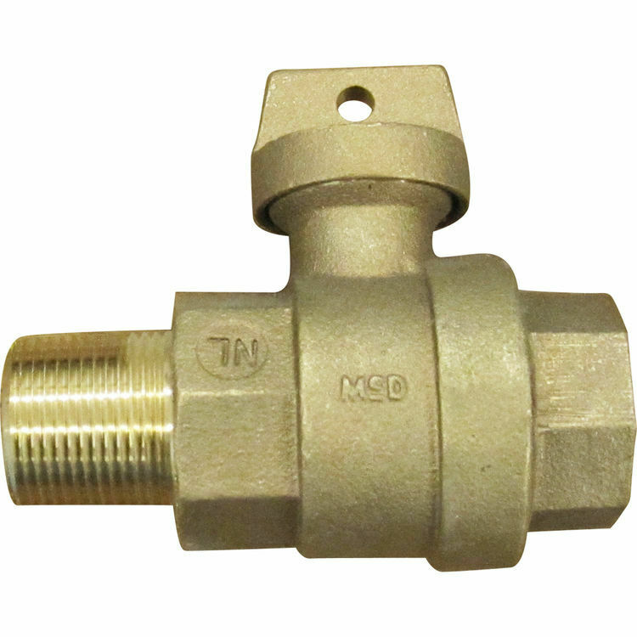



**Auto Draft Fee Waived**

Sign up for Auto Draft with your **Bank Account** for **NO FEE**!! **Please note that if you use your Credit Card there is a 3.5% fee.**

* Go to the website @ [www.pocid.org](https://l.facebook.com/l.php?u=http%3A%2F%2Fwww.pocid.org%2F%3Ffbclid%3DIwAR1RcLWgEPAebm-ZNp70EGMkdf6QCoy3I49g8QBfZVBynTieC7M20Sd3RQk&h=AT1Prcf9xoYbUFAOUcPOxbg7MUs3wGQteTOXAnPb0XsyQCf_6nsq8S0ZLhR6gLylSJ80jN-WzzwV6QRPV52KfYSAijxP7_rrHN-19yrmajQQWAYzCSAZEvriyvu3Vy86IA&__tn__=-UK-R&c%5b0%5d=AT0It4OKA8z8brbuTEnJqAzCMRBHMWLw_RM2miWdY3o9svX_12_RvDSSq26YlU-s4v5tTlpPMHOUpK6s8jjULL9C2sIy7JIpjBjH7NA7aYPhlrnfv6gpcwlxJ7UoVdNXPbOcIl0SqPXJ6ooseBqevuzRmBexfu8PNPwqE-P6XUSBxA) - select Bill Payment and log in or set up an account and then select I want to set up auto pay.

* Go online to [https://www.pocid.org/all-forms](https://www.pocid.org/all-forms?fbclid=IwAR0ESAVw63Q2_aWjDFNmgcVcvFVRqAQk7sO08dwwTp0zozGdy7qZCfYrRZc) and select POCID ACH & Credit Card Form then fill out a form and email it to [www.pocid@pocid.org](http://www.pocid@pocid.org)

* Contact the Port O'Connor Improvement Office at 361-983-2652



