POCID ACH Withdraw Information
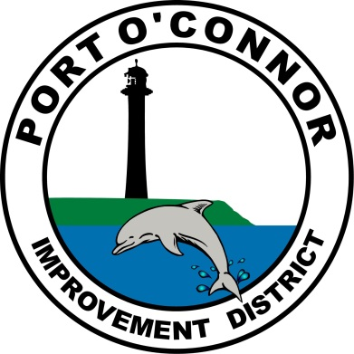

P.O. Box 375, Port O’Connor, TX 77982 * Phone: 361-983-2652 * Fax 361-983-2235

Agreement Type | ____ New Agreement _____ Change Account (please choose one)  ACH Bank Draft Fee is FREE ACH Credit Card Fee is 3% of Payment
Customer  Information  Please Print | Name on POCID Account ___________________________________________  POCID Account # __________________________________________________  Mailing Address ___________________________________________________  Service Address ___________________________________________________  Daytime Phone# __________________________________________________
Complete for Checking  Account Only | Please tape a voided check for checking account.  (Do not staple).
Change Bank Account | NEW BANK:  Routing Number: __ __ __ __ __ __ __ __ __  Account Number: _____________________  CHANGE  TO  EXISTING BANK:  Routing Number: __ __ __ __ __ __ __ __ __  Account Number: ____________________________
Complete for  Credit Card  Please print | Name on Credit Card _________________________________________________  Billing Address ______________________________________________________  Credit Card Number __________________________________________________  Expiration Date __________ Security Code ___________VISA/MC/AmEx/Disc
Please Sign | Sign ___________________________________________ Date ___________
Completed Forms can be Emailed to pocid@pocid.org

