- Monthly Newsletter  February 2021  Important Dates:  POC Water Board Meetings are held on the second Thursday of each month @ 1pm  February 11th * March 11th  Roll off Trash Bin  First Saturday of each month behind the POCID Office from 8am -2pm or UNTIL FULL  February 6th * March 6th  April 3rd * May 1st  Billing  Bills are mailed by the 1st  of each month and are due  on 20th of every month  and a late fee will be accessed  on the 21st unless that falls  on a weekend and then it  will be due the following  Monday.  Payment Methods:  Credit Card*Mail*Automatic  Bank Draft*Automatic Credit Card Draft*In Person*Payment Drop  Box* Bill Pay through your  Financial Institute  - Contact Us  POC Water  39 Denman DR  PO Box 375  Port O’Connor, Texas 77982  361-983-2652  pocmud@tisd.net  https://www.pocid.org/  https://www.facebook.com/POCIDofficial/  Vision Statement  POCID is a proactive organization making a positive impact on the community while implementing best management practices to promote sustainable success.  Mission Statement  To proactively and efficiently  manage the affairs of the District  for the benefit of its customers,  protect the health of the community, produce safe drinking water in adequate quantities, offer  competitive rates, assure  financial stability, and practice excellence in customer service. | “POC Water”  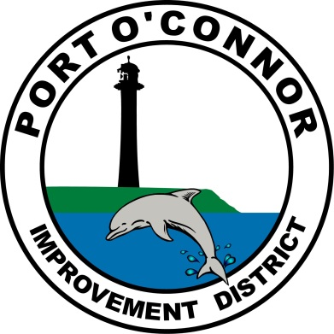  P.O. Box 375/ 39 Denman Dr  Port O’ Connor, Texas 77982  Phone: (361) 983-2652  BOIL WATER NOTICE…….WHY?  Per TCEQ “When a public water system (PWS) issues a Boil Water Notice (BWN) to their customers, it indicates the water in the distribution system may be unsafe for consumption or may pose an acute health risk. A BWN is intended to reduce the possibility of waterborne illnesses resulting from consuming water which may contain harmful microbes.  It is important that customers of any water system that has issued a BWN to not drink the water without first boiling it as directed by the water provider.”  Note that in the wording above it states “…system may be unsafe.”. Therefore, anytime a water provider identifies a problem that could lead to any compromise of the water quality they implement the necessary steps required by the TCEQ.  The Boil Water Notice issued on January 15th was one of those necessary steps. In an effort to repair a main break on a 6” Water Main a decision was made which lowered the pressure to below 20 psi. This pressure drop is what triggered the need for the Boil Water Notice.  I am always available to answer any questions about our water and wastewater systems so feel free to give me a call (361-983-2652) or drop by the office.  Oscar Pena  District Manager  Show some love to your Water System Team!  PROJECT UPDATE  TWDB Project No. 21750  All the work that was originally designed by Brown and Gay and the work from change orders to the project has been completed. The Board needs to make a decision on how to best use these funds. One potential project that would be of the approximate amount for construction would be to construct the RO Outfall Line.  2016 TWDB Projects  Vacuum Station No. 2 Force Main  Lester Contracting has completed the project. A Certificate of Final Completion has been issued.  Vacuum Sewage Collection System Upgrade  Reddico Construction has completed construction and the final inspection has been completed. The project is in the close out phase.  Phase II Water System Improvements  R&A is currently working on this project. The excess rain that we have experienced the last 3 weeks have the project on hold.  2020 TWDB DW SRF Bond Projects  The archeological survey required by the Texas Historical Commission has been completed and final environmental submittals have been made to TWDB. TWDB has indicated that it will be the first part of 2021 before their review and approval will be completed. The projects cannot be put out for bids until TWDB has approved all the environmental. A public hearing on the environmental was held on December 10, 2020.  New Water Wells  The plans for the water wells have been completed and approval from TCEQ was received by letter dated 6/22/20. Plans and Specifications will shortly be submitted to TWDB but they will not issue an approval until the environmental is approved.  Arrangements are being made to make a submittal to the Calhoun Co. GCD for drilling and operation permits for the proposed wells.  Well Transmission Lines and RO Outfall  The plans for the well lines and RO discharge line are nearing completion subject to a revision to include the line to the new Well No. 7 location. Submittal of the plans to TCEQ and TWDB is waiting on final design revisions on the new Well No. 7 location.  Raw Water Ground Storage Tank  The plans and specifications for this project are complete and were approved by TCEQ by letter dated 6/2/20. Formal approval will not be given by TWDB until all environmental conditions have been met.  Reverse Osmosis Treatment Facility  Design for this major project is underway and is being modified to provide additional capacity to serve LaSalle. This is a major design project that includes a building, equipment, piping, electrical, controls, HVAC and chemical treatment.  Evaluation of design relative to including LaSalle is being done. It looks like the design modifications will be relatively minor. I would like to add at lease 150 gallons per minute of finished water to the RO facility. This can be done by adding 3 more filter tubes on top of what was previously being proposed. It will require raising the ceiling height in the RO building by a foot and increasing the footprint of the building as needed to increase the size of the pre-filters and add space for additional pumping capacity.  None of the 2020 Bond projects can be bid until all the environmental and permitting has been completed and approved by TWDB. For TWDB to approve the completed Environmental Document the following are required.  - Final design of all project components (See individual Project status above)  - Engineering Feasibility Report (Completed and in Application)  - Public meeting (held on Dec 10)  There will then be an approximate three-month time for review and approval by TWDB, provided there are no major problems with any of the submittals. Therefore, the earliest that one of the projects can be advertised for bids will be in the March 2021 – April 2021 time frame.  Because the wells will take the longest time for approval, at least 60 days after they are completed, the wells will be the first project of the 2020 Bond fund projects to bid. Bidding of the other projects will be staged as appropriate depending on the time required for completion of the wells and to minimize on-site conflicts with multiple projects and contractors.
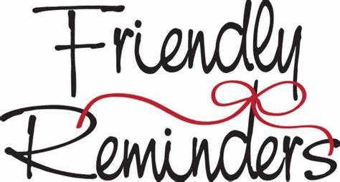
One of our biggest concerns is maintaining the integrity of our sewer system in order to provide good sewer service to our customers. As most Port O’Connor
residents know, our sewer system is a
vacuum system which must stay sealed
at all times to work properly. If you
received a letter with infiltration
Issues it is important that you repair
them. If you don’t repair the issue, we
will repair them and bill you the cost.
Please call the POCID Office @
361-983-2652 with any questions.

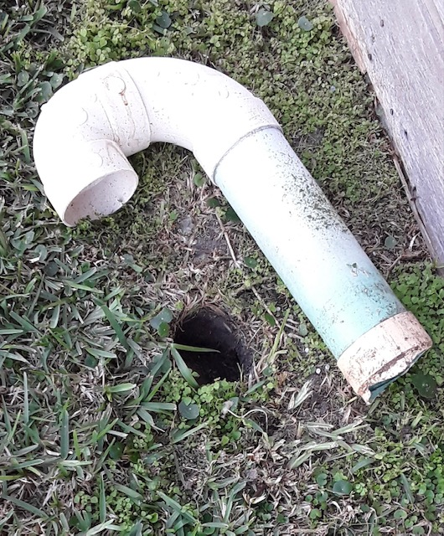
Is your account a TEMP account? Call us to schedule a for Customer Service Inspections (CSI) to be in compliance with the state. This is to make sure you don't have any lead pipes or cross connections.

Letter from the President!

In July of 2019, the POCID Board of Directors made one of the best decisions to date by hiring Oscar Pena as our District Manager. A well respected and highly sought-after professional, Oscar came out of retirement to help lead POCID back to a well-run and forward-looking district.

Oscar started his career by serving our country for 10 years in the US Army. In 1991 Oscar went to work for the City of Port Lavaca and eventually became the Public Works Director. After a 27-year career he retired as one of the most respected Directors of Public Works on the Texas Coast. Numerous cities tried to coax him out of retirement but it wasn’t until Oscar was approached about the POCID Manager’s position did he agree to get off his motorcycle and get back to doing what he does best.

Under Oscar’s leadership, the staff has come together as a team and together brought the district into an efficient and professionally run organization. Oscar always tries to do what is best for our ratepayers and is fiercely loyal to the district. Although he is not known for his bedside manners, Oscar is “the Man” if you want the truth and the facts! Thank you, Oscar, for your dedication to the district.

Now for a few updates. As we start the New Year, big things are in store for POCID including:
- new water wells and R/O system will begin construction;
- a new elevated storage and ground storage will be constructed;
- the old elevated storage and ground storage will go thru a full rehab;
- major areas of the district that do not currently have access to water and sewer will have those services added;
- upgrades to the current vacuum stations will take place;
- a new vacuum station will be added;
- a new POCID office and meeting facility will be constructed;
- a vote to merge La Salle (Sanctuary) into the POCID family will occur;
- as well as many other projects designed to update the current system and plan for the future growth of the district.

We hope through our newsletter, Dolphin Talk articles, social media posts, and monthly meetings, you are being informed of all district projects and updates. All of us from the Board to the Staff of POCID strive to be helpful at all times and informative at all time. We welcome your input and questions.

Danny McGuire
POCID Board President
Check out our Website @ www.pocid.org
*Sign up for Alerts
* Pay your bill
* Applications/Forms
* Sign up for Auto Draft
* Current Projects
* Agendas/Minutes
* Updates
* Sign up for paperless billing

Customer Service Valve
Remember to install a customer service valve on your side of the meter. Please turn your customer service valve off if you live out of town to keep any water leaks turning into a disaster. Turning on/off the POCID meter is against District Policy.
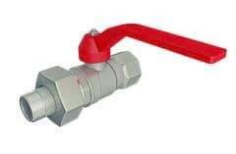

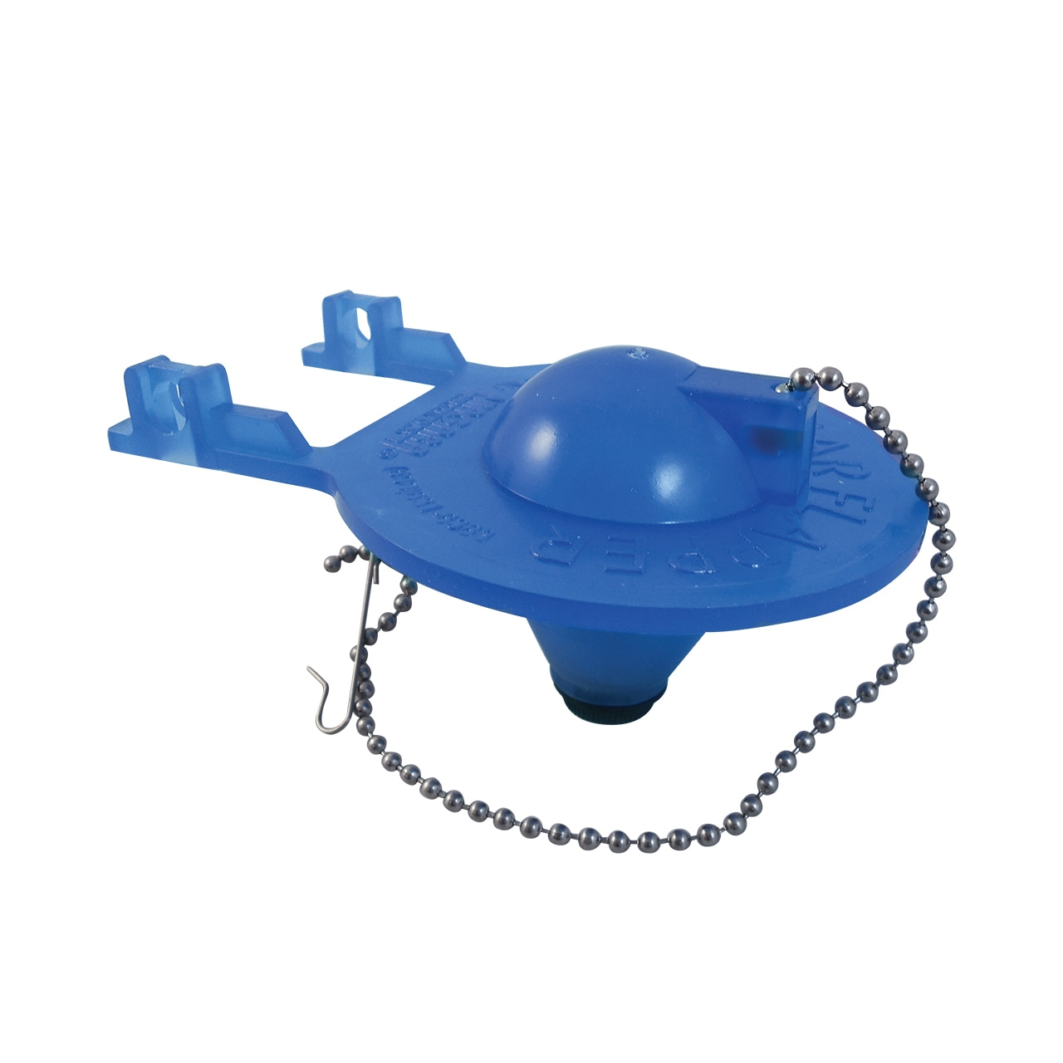
The average leaky toilet can waste about 200 gallons of water per day. That's over 6,000 gallons a month for just one leaking toilet! Some toilets may produce a running water sound that is easy to hear. You should replace your flapper every 2 years.
To Test A Toilet Leak
- Drop a few drops of dark food dye in the toilet tank.
- Don’t flush the toilet for about an hour.
- After an hour check the toilet bowl.
- If food coloring has appeared in the bowl you have a leak.

POC Water
PO Box 375/39 Denman Dr
Port O’Connor, TX 77982
361-983-2652

