- Monthly Newsletter  June 2021  Important Dates:  POC Water Board Meetings are held on the second Thursday of each month @ 1pm  June 10th * July 8th  Roll off Trash Bin  First Saturday of each month behind the POCID Office from 8am -2pm or UNTIL FULL  June 5th * July 3rd  Billing  Bills are mailed by the 1st  of each month and are due  on 20th of every month  and a late fee will be accessed  on the 21st unless that falls  on a weekend and then it  will be due the following  Monday.  Payment Methods:  Credit Card*Mail*Automatic  Bank Draft*Automatic Credit Card Draft*In Person*Payment Drop  Box* Bill Pay through your  Financial Institute  - Contact Us  POC Water  39 Denman DR  PO Box 375  Port O’Connor, Texas 77982  361-983-2652  pocmud@tisd.net  https://www.pocid.org/  https://www.facebook.com/POCIDofficial/  Vision Statement  POCID is a proactive organization making a positive impact on the community while implementing best management practices to promote sustainable success.  Mission Statement  To proactively and efficiently  manage the affairs of the District  for the benefit of its customers,  protect the health of the community, produce safe drinking water in adequate quantities, offer  competitive rates, assure  financial stability, and practice excellence in customer service. | “POC Water”  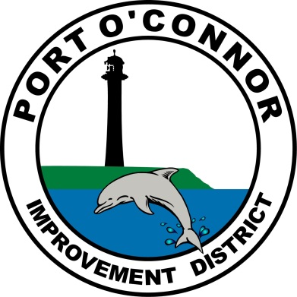  P.O. Box 375/ 39 Denman Dr  Port O’ Connor, Texas 77982  Phone: (361) 983-2652  New Port O’Connor Admin Building on the Horizon  Residents of Port O’Connor are familiar with the water district building located along TX 185 (Adams Street). Over twenty years ago, when the Port O’Connor Improvement District was formed, then board president, Teddy Hawes, had only a shoestring budget to create facilities for the operations staff of the District. An old home was identified and moved to this location as a temporary measure to get the District started.  The building has lasted much longer than was intended, and while repairs have kept things functional with painting, new sheetrock, and plumbing fixes, the building is in need of many repairs and upgrades. The roof is in need of repair, rotten boards and floors need to be replaced, and there are structural concerns after recent storm events. Additionally, the HVAC system needs to be replaced and wiring updated. Bids were sought to repair the existing building. After receiving cost estimates and inspection reports, the Board of Directors hired an architectural firm to develop proposals for a new building. Once the firm submitted proposed plans and a budget, the Board of Directors decided it was in the District’s best long-term interest to build a new office building.  On Monday, May 17th, 2021 the District solicited bids for the construction of a new office. With this new construction, there will be improved staff offices, a larger conference/board room for meetings, the ability to take drive through payments, a training room to enable the District to provide onsite training instead of having to have employees travel, showers for District employees to use after working in the field, a records retention room that is in compliance with state laws, and a new indoor payment location. The outward façade will be a “barndominium” style, and the bid awards should begin in June with construction anticipated to commence prior to the 4th of July holiday.  .  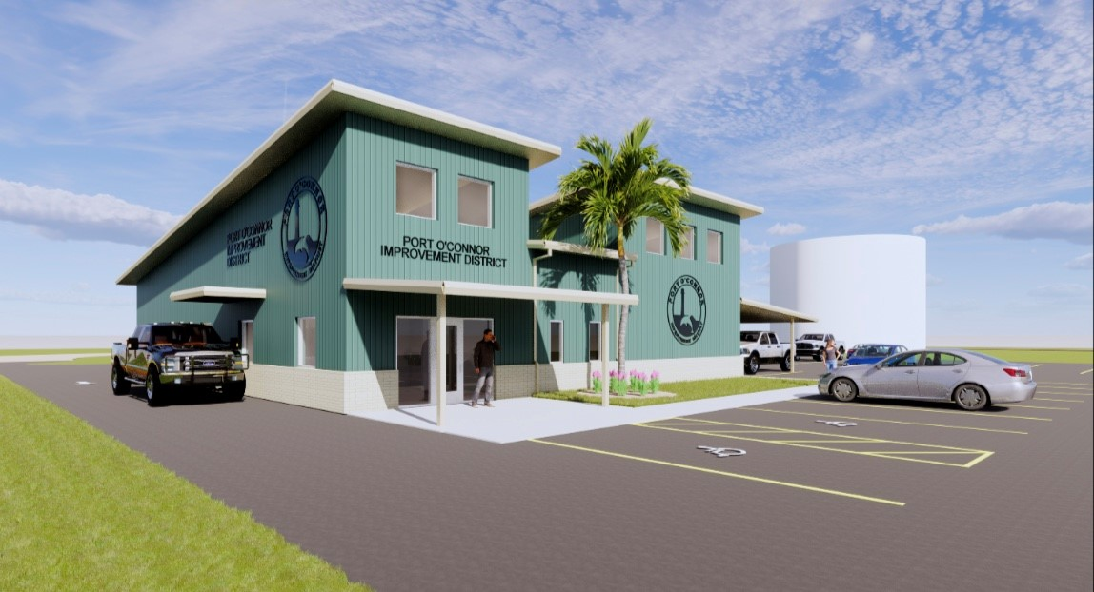  Sewer Surcharge  Sewer surcharge refers to the overloading of the sewer beyond its design capacity due to inflow and infiltration of water. What this means is that the lines are full and cannot take anymore sewage.  Attempting to flush when a sewer system is surcharged is only going to create overflows at some open point in the system.  Sometimes these open points are intentional such as removing a cleanout or “candy cane” during a heavy rain. Sometimes these points are breaks in sewer lines at connections or underground.  When the system finally gets to go back to normal these overflow points then become inflow and infiltration points which continue to create problems for the system and could lead to pump failures within the collection system or the sewer.  Below is a picture of one of the sewer pumps at Vacuum Station #2. Once this pump failed our ability to pump sewer out from the collection system was cut in half. One of the items stuck in the impeller is a piece of PVC pipe. This debris is not part of what gets flushed into the system but probably made its way into the sewer lines through and open clean-out or candy cane.  The system was designed to handle the domestic sewer generated by the residents of Port O’Connor and is constantly upgraded to accommodate growth. However, it was not designed to drain peoples yards, RV Parks, patio drains, outdoor fish cleaning tables, outdoor showers, etc. District personnel will be working more diligently to identify what goes into our sewer systems to ensure it is within the POCID Rules and Regulations.  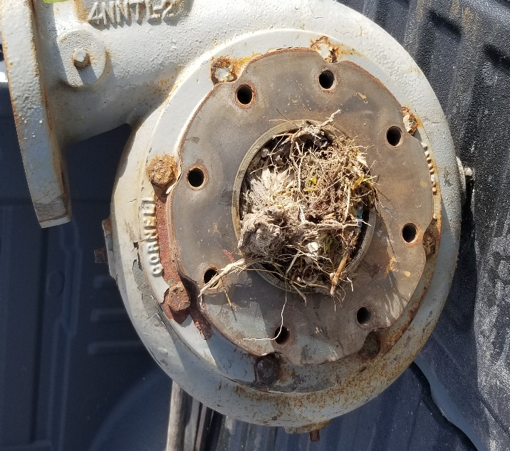  We really appreciate your patience during this heavy rainfall event as we continue to identify and correct any problems out in the field. If you see anything on your property or out in the community that might look like a potential overflow point, please call the POCID office @ 361-983-2652.
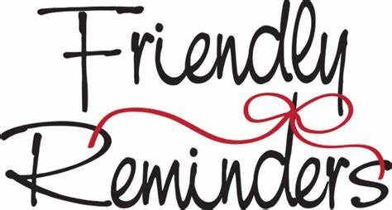

care of and you may see them on POC properties. They will be provided POCID signs to identify their vehicles.
We have customers who are in need of Backflow Inspections for RV Parks, irrigation systems, etc that are past due. Periodically we hire consultants to do these inspections to meet TCEQ Compliance. We have a consultant working with the District to get this taken

Monthly Roll Off Bin
On the first Saturday of every month, POCID provides a roll off bin for large trash items. The bin is open behind the District Office on the first Saturday of each month from 8am to 2pm OR UNTIL FULL. POCID is extremely happy that POC customers take advantage of this service as it usually fills up much sooner than 2pm.

This is for residential accounts and not for commercial waste. NO paint, tires, gas, freon, batteries, brush or any unacceptable waste in the bin. Make sure you bring your POCID bill to utilize this service. POCID customers must sign in with their name & POC physical address.

Upcoming Dates: June 5th & July 3rd
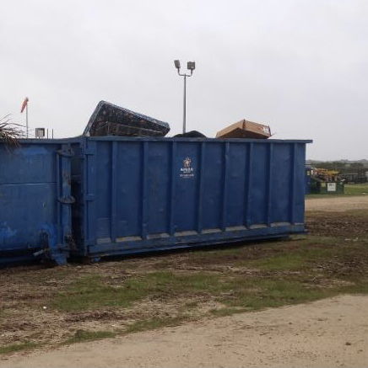
Beginning around June 7th, Vanguard will begin installing AMI meters. For the POC residents that chose to have us install a new customer service valve, they will be installing those at the same time. District rules require a customer service valve withing 3 foot of the meter.
The District is very excited to bring this to POC. The endpoint for the meter signal is mounted on the lid and connected to the meter with a small cable. Please refrain from going into the meter box to prevent any possible damage.
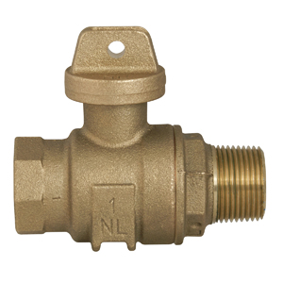

Irrigation Permits
All sprinkler systems require a permit completed and turned in to POCID Office before installation. After installation a backflow inspection is required.
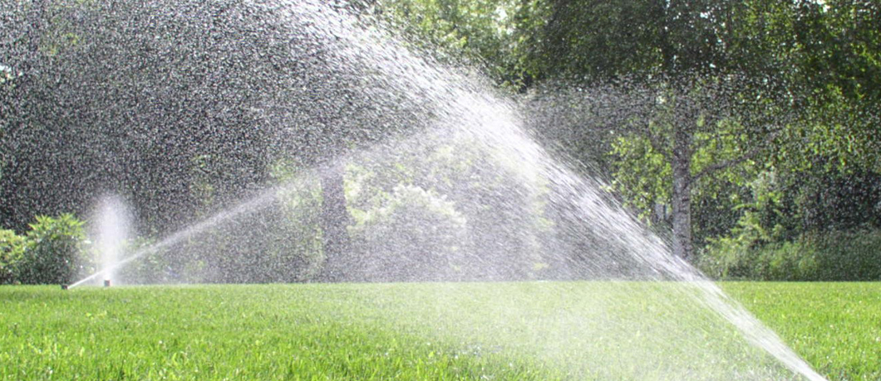
Check out our Website @ www.pocid.org
*Sign up for Alerts
* Pay your bill
* Applications/Forms
* Sign up for Auto Draft
* Current Projects
* Agendas/Minutes
* Updates
* Sign up for paperless billing

POC Water
PO Box 375/39 Denman Dr
Port O’Connor, TX 77982
361-983-2652

