*Please report any possible water leaks, broken candy canes or any hissing or vacuum sounds coming from candy canes or pits.

*We do Monthly flushing so at times you will see the hydrant running this is to ensure our water quality

* We ask if you could put your number on the outside of your homes to able to find your location better.

*Please make sure the information on your account is updated as we do try to call you if we think you have a leak or a problem.

Regular Board Meeting
2nd Thursday of each month

Roll off Bin
1st Sat of every month –
Jan 8th , Feb 5th , March 5th
Bring your POCID Bill
8am to 2pm or till full

Check out our
Website & Facebook page

Sign up for Alerts
Pay your bill
Applications/Forms
Sign up for Auto Draft
Current Projects
Agendas/Minutes
Updates
Sign up for e-billing
Port O’Connor Improvement District
P.O Box 375 * Port O’Connor Tx 77982
Phone: 361-983-2652
Website: www.pocid.org
Email: pocid@pocid.org
Facebook: https://www.facebook.com/POCIDofficial

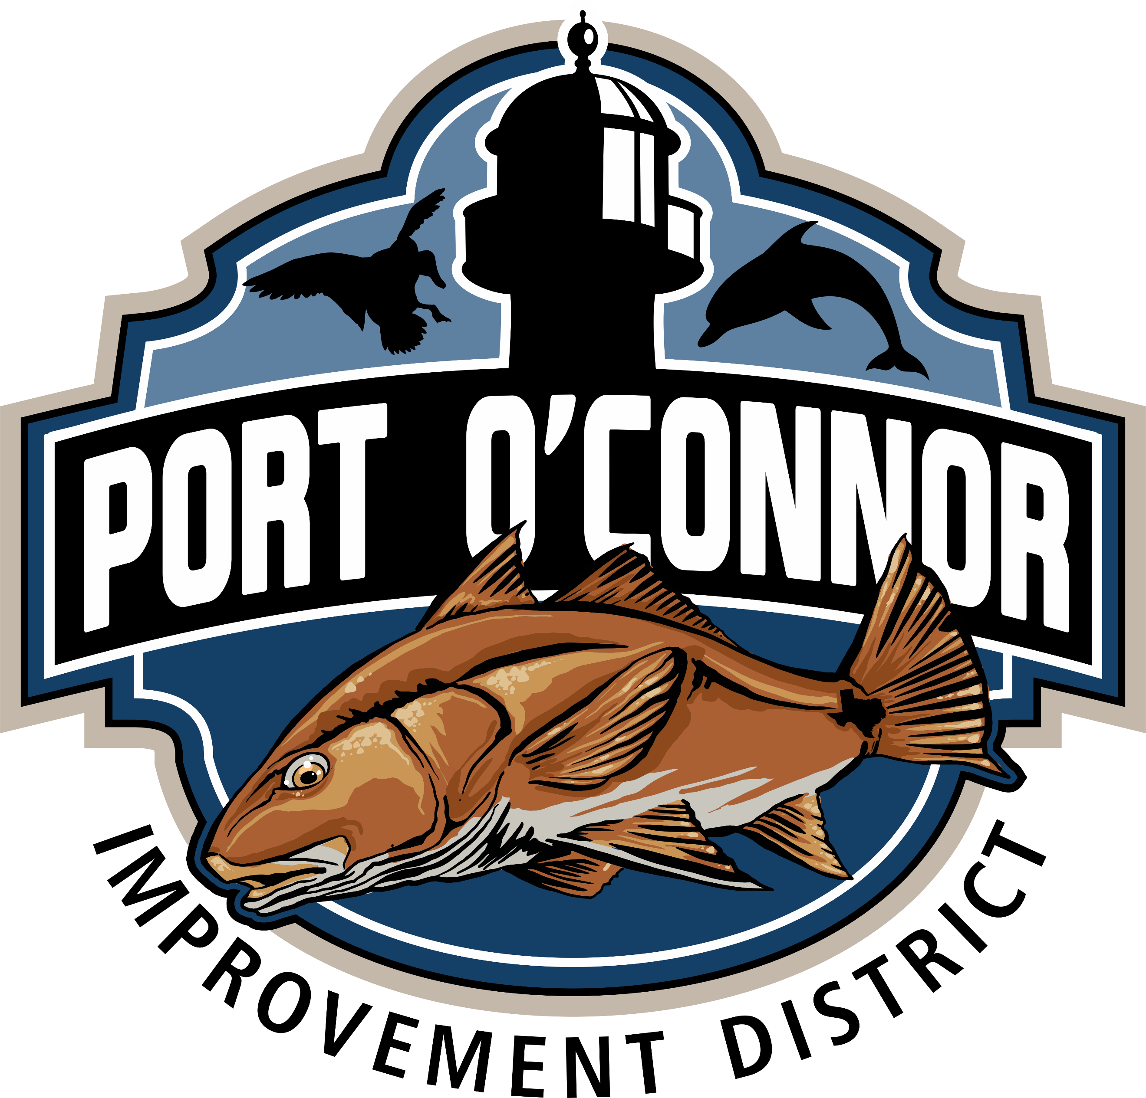
If you ever have any questions or concerns, please feel free to call the District Office. If we don’t know the answer, we will find someone who does.
Our customers are our priority.

