- Monthly Newsletter  June 2022  Important Dates:  POC Water Board Meetings are held on the third Thursday of each month @ 1pm  June 16th * July 21st  Roll off Trash Bin  First Saturday of each month behind the POCID Office from 8am -2pm or UNTIL FULL  June 4th * July 9th  Billing  Bills are mailed by the 1st  of each month and are due  on 20th of every month  and a late fee will be assessed  on the 21st unless that falls  on a weekend and then it  will be due the following  Monday.  Payment Methods:  Credit Card*Mail*Automatic  Bank Draft*Automatic Credit Card Draft*In Person*Payment Drop  Box* Bill Pay through your  Financial Institute  - Contact Us  POC Water  39 Denman DR  PO Box 375  Port O’Connor, Texas 77982  361-983-2652  pocid@pocid.org  https://www.pocid.org/  https://www.facebook.com/POCIDofficial/  Vision Statement  POCID is a proactive organization making a positive impact on the community while implementing best management practices to promote sustainable success.  Mission Statement  To proactively and efficiently  manage the affairs of the District  for the benefit of its customers,  protect the health of the community, produce safe drinking water in adequate quantities, offer  competitive rates, assure  financial stability, and practice excellence in customer service. | “POCID”  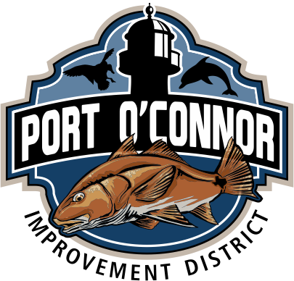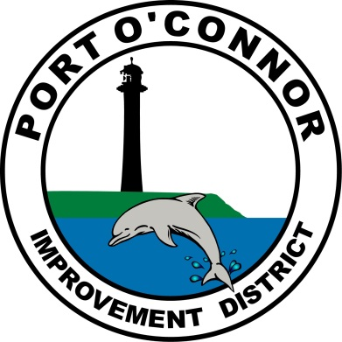  District Works in Progress  Facility Upgrades  As many of you have noticed, there is a lot of ongoing District activity in the area. The District is nearing completion of the rehabilitation of the elevated storage tank. This work involved sand blasting and painting the interior and exterior of the tanks as well as safety, access, and lighting improvements. This work is being performed by Tank Pro, Inc. at a cost of $370,318.00. To finish out the storage tank projects, rehabilitation of and improvements to the existing ground storage tank are underway. NG Painting, LP is working on this rehabilitation project for a total projected cost of $287,000.00. This work started on May 9th and is expected to be complete by mid-July. While this tank is offline and being serviced, the District is employing the use of portable water storage tanks to continue providing water to the District’s customers. Two more storage tank projects are slated for construction in the next couple years: a 135,000-gallon raw water storage tank to store groundwater from proposed wells prior to reverse osmosis filtration, and a second 500,000-gallon ground storage tank to store potable water prior to distribution to customers, providing redundancy to the existing ground storage tank, additional flexibility in operations, and meeting peak summer demands.  The work on the new District office building continues; the District was informed the building should be substantially complete and ready for occupancy in mid-June. District personnel will be utilized in moving into the new office  Water System Improvements  There are also multiple water lines being installed in the District. The Board of Directors analyzed the District service area to determine where lines need to be extended and upsized. While not every line can be laid at this time, the District Manager has selected priority areas, such as the main commercial area on Adams Street, and areas with multiple homes waiting for service to be available. The District’s goal is to provide more water and sewer service availability to residents in the District’s service area. The current project includes improvements at Water and 10th, along Adams in several locations, and along Polk, 9th, 10th and Lewis.  Lester Contracting is completing the project for a projected total cost of $329,238.25. Anticipated future projects are the installation of additional isolation valves and fire hydrants for improved operability of the system as well as additional extensions and upsizings.  Sewer System Upgrades  Work on the sewer system continues. The Directors have made the sewer system improvements the District’s number one priority in order to alleviate the recent issues in the system that occur with heavy rainfall. The smoke testing is complete and where there were issues on private property and private lines, the customers have been notified of the need to take remedial action. Notices to 122 customers were sent informing customers of necessary corrective action. Follow up to ensure this work has all been completed will continue. The cost of the smoke testing was $138,990.00. District crews have also been busy installing the monuments on the air intakes previously installed by the contractor on the collection pits. The air intake installation eliminated the candy canes which will help minimize inflow of stormwater into the sewer vacuum system. The District received a bid of $89,115.00 for the labor to perform this part of the sewer system upgrades, but elected to utilize existing district crews in order to reduce the costs. While the work will take longer to complete, the savings was substantial.  Plans are also proceeding on new vacuum stations adjacent to the existing vacuum stations. Once engineering and TCEQ approval is complete the projects will be advertised for bids on the construction contracts. Construction is expected to start on Vacuum Station No. 4 (adjacent to Vacuum Station No. 1) in September 2022 and start on Vacuum Station No. 5 (adjacent to Vacuum Station No. 2). The anticipated construction cost of the new vacuum stations is $3,375,000.  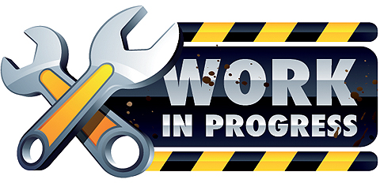

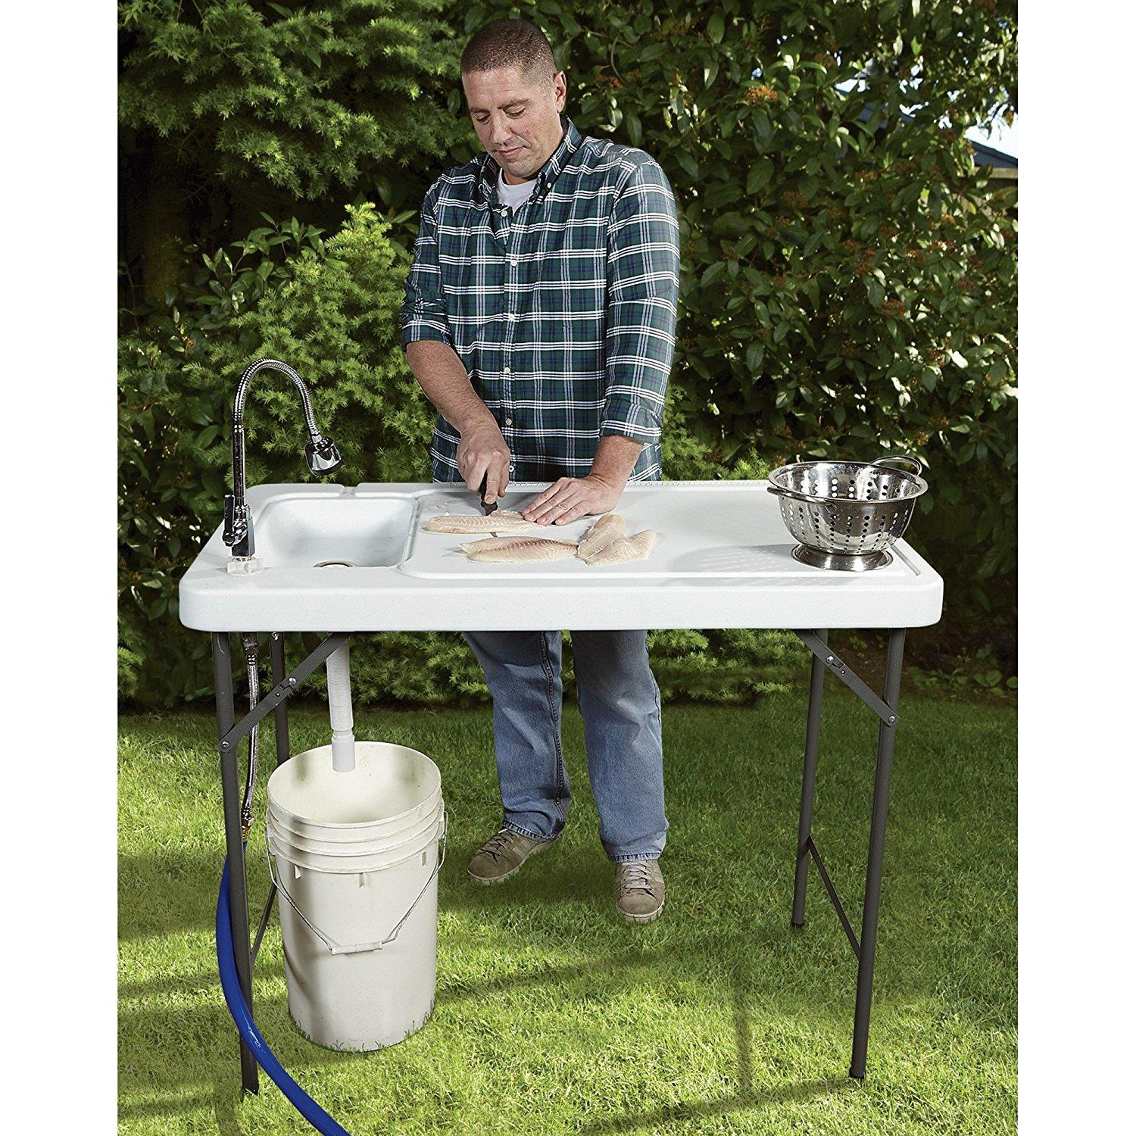
ALL Outdoor Showers and fish cleaning stations need a permit & an inspection per District Policy. We are actively identifying these to insure we do not have an excess of rainwater in our sewer system. The smoke testing did help us with these. Please
call the
District office @
361-983-2652 to obtain the required permit.

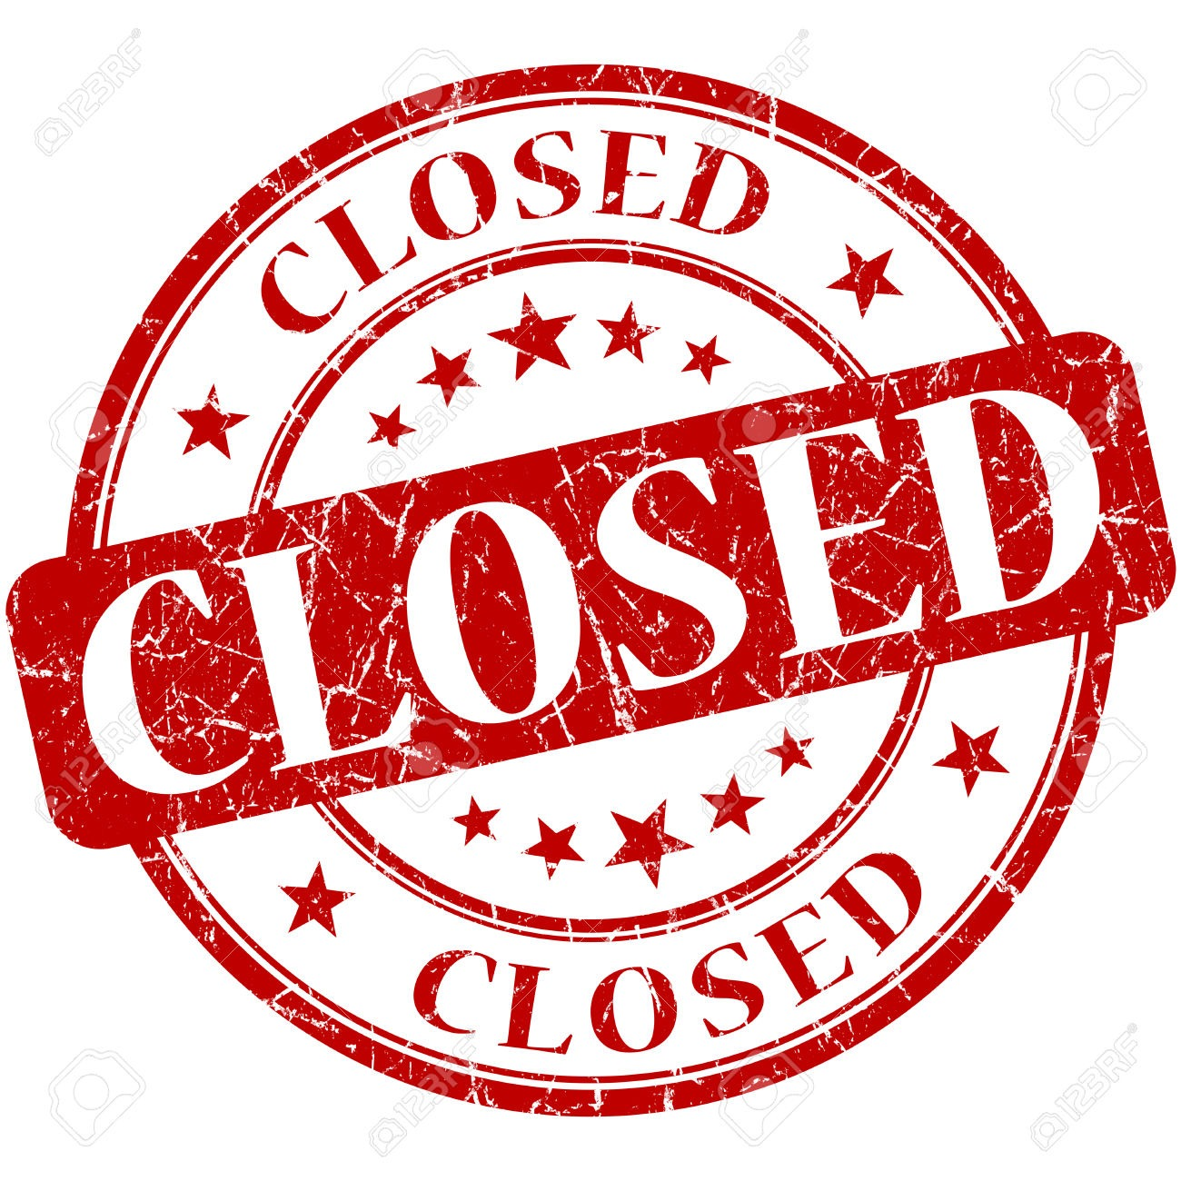

If you are closing your account, you must call the office and do so. You will continue to receive a bill until it is closed.
The buyer cannot close your account.
Auto Draft Fee Waived

Those of you who have been utilizing the ACH payment option, there is NO CHANGES NEEDED ON YOUR PART and you will see, on your next statement, that the fee has been removed. If any of our customers would like to start using this payment option:
* Go to the website @ www.pocid.org - select Bill Payment and log in or set up an account and then select I want to set up auto pay.
* Go online to https://www.pocid.org/all-forms and select POCID ACH & Credit Card Form then fill out a form and email it to www.pocid@pocid.org
* Contact the Port O'Connor Improvement Office at 361-983-2652
Irrigation Permits
All sprinkler systems require a permit completed and turned in to the POCID Office before installation. After installation a backflow inspection is required.
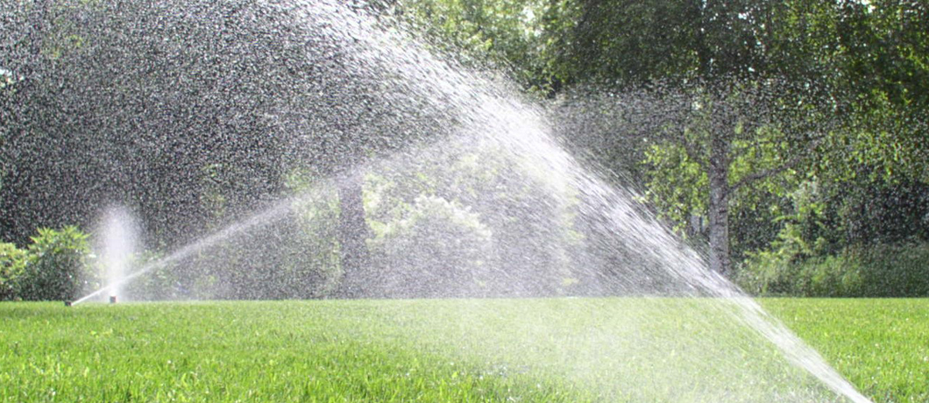
Check out our Website @ www.pocid.org
*Sign up for Alerts
* Pay your bill
* Applications/Forms
* Sign up for Auto Draft
* Current Projects
* Agendas/Minutes
* Updates
* Sign up for paperless billing

