|  |  |  |  |  |
| --- | --- | --- | --- | --- |
| |  | | --- | | Monthly Newsletter  July 2023 | | |  | | --- | | Important Dates:  **POC Water Board Meetings are held on the third Thursday of each month @ 1pm**    *July 20th * August 17th*  **Roll off Trash Bin**  **First Saturday of each month behind the POCID Office from 8am -2pm or UNTIL FULL**  *July 1st * August 5th* | |   **Billing**  ***Bills are mailed by the 1st***  ***of each month and are due***  ***on 20th of every month***  ***and a late fee will be assessed***  ***on the 21st unless that falls***  ***on a weekend and then it***  ***will be due the following***  ***Monday.***  **Payment Methods:**  *Credit Card*Mail*Automatic*  *Bank Draft*Automatic Credit Card Draft*In Person*Payment Drop*  *Box* Bill Pay through your*  *Financial Institute*  Contact Us  POCID  39 Denman DR  PO Box 375  Port O’Connor, Texas 77982  361-983-2652  pocid@pocid.org  <https://www.pocid.org/>  <https://www.facebook.com/POCIDofficial/>  **Vision Statement**  *POCID is a proactive organization making a positive impact on the community while implementing best management practices to promote sustainable success.*  **Mission Statement**  *To proactively and efficiently*  *manage the affairs of the District*  *for the benefit of its customers,*  *protect the health of the community, produce safe drinking water in adequate quantities, offer*  *competitive rates, assure*  *financial stability, and practice excellence in customer service.* | **“POCID”**      Why 911 Addresses are Important  What is a 911 address?  It is the address of a physical structure that is primarily used to help emergency service personnel find the location.  The District also uses these numbers to identify residences and locations for service calls, meter reading, system alerts and to respond to customer calls.  Thus, it is very important that these numbers are displayed.  Unfortunately, in Port O’Connor where all mail is distributed at the post office and where many residences are secondary homes, these numbers are not present on a lot of homes.  The lack of numbers could cost vital minutes in an emergency situation with emergency responders unable to locate the residence in question.  This will become more and more of an issue as Port O’Connor continues to grow.  From the District’s perspective, the absence of identifying numbers leads to a very inefficient use of District resources—including time and funds.  Therefore, the District urges all customers to please have their 911 addresses posted on the premises.  Fast And Easy Arch House Number Plaque  If you do not know your 911 address, you can obtain it by calling Rachel at Calhoun County Emergency Management; her number is 361-552-5455.  Please do not call the District office to obtain your number because only the owner of the property in question is allowed to attain that information from Emergency Management.  Your posting of the 911 address on your premises will greatly aid the District in serving you and the District’s other customers  Where to Get Modern House Numbers Signs + Plaques | Emmaline Home in ...  Emergency provider organizations offer the following guidelines for the increased visibility of 911 addresses:   1. The preference is for white numbers against dark backgrounds.  The guidelines discourage the use of black numbers because they are very difficult to see at night (as are similarly colored numbers and backgrounds). 2. The numbers should be located near the front door and within the area illuminated by the front porch light for night-time visibility. 3. The numbers should be at least four inches in height. 4. The numbers should be readily seen from the road. 5. Care should be taken to keep shrubbery and other items from blocking the numbers from the view of emergency personnel. |

**You now have the option to pay 24/7 by credit card by calling**

**844-923-2162.**

**We will accept Visa, MasterCard and Discover for a 3.5% service fee.**



**Irrigation Permits**

**All sprinkler systems require a permit completed and turned in to the POCID Office before installation. After installation a backflow inspection is required.**

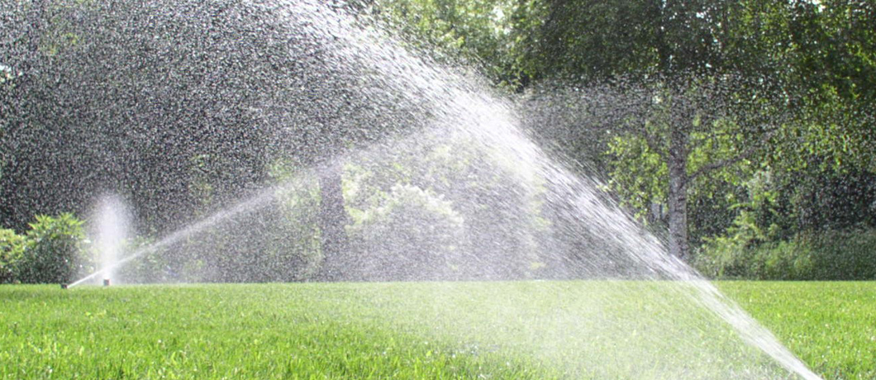

Check out our Website @ [www.pocid.org](http://www.pocid.org)

**\*Sign up for Alerts**

**\* Pay your bill**

**\* Applications/Forms**

**\* Sign up for Auto Draft**

**\* Current Projects**

**\* Agendas/Minutes**

**\* Updates**

**\* Sign up for paperless billing**

**POCID Rules and Regulations require all customers to have a customer service valve outside their meter box within 3 feet of the meter box.**

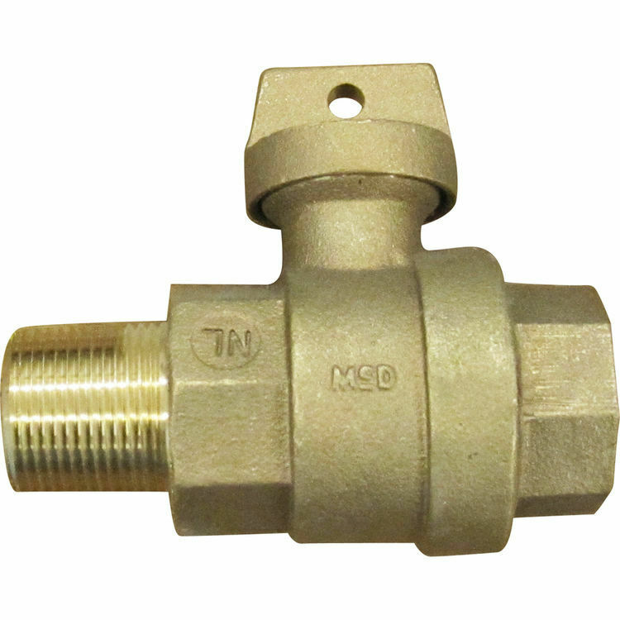



**Auto Draft Fee Waived**

Sign up for Auto Draft with your **Bank Account** for **NO FEE**!! **Please note that if you use your Credit Card there is a 3.5% fee.**

* Go to the website @ [www.pocid.org](https://l.facebook.com/l.php?u=http%3A%2F%2Fwww.pocid.org%2F%3Ffbclid%3DIwAR1RcLWgEPAebm-ZNp70EGMkdf6QCoy3I49g8QBfZVBynTieC7M20Sd3RQk&h=AT1Prcf9xoYbUFAOUcPOxbg7MUs3wGQteTOXAnPb0XsyQCf_6nsq8S0ZLhR6gLylSJ80jN-WzzwV6QRPV52KfYSAijxP7_rrHN-19yrmajQQWAYzCSAZEvriyvu3Vy86IA&__tn__=-UK-R&c%5b0%5d=AT0It4OKA8z8brbuTEnJqAzCMRBHMWLw_RM2miWdY3o9svX_12_RvDSSq26YlU-s4v5tTlpPMHOUpK6s8jjULL9C2sIy7JIpjBjH7NA7aYPhlrnfv6gpcwlxJ7UoVdNXPbOcIl0SqPXJ6ooseBqevuzRmBexfu8PNPwqE-P6XUSBxA) - select Bill Payment and log in or set up an account and then select I want to set up auto pay.

* Go online to [https://www.pocid.org/all-forms](https://www.pocid.org/all-forms?fbclid=IwAR0ESAVw63Q2_aWjDFNmgcVcvFVRqAQk7sO08dwwTp0zozGdy7qZCfYrRZc) and select POCID ACH & Credit Card Form then fill out a form and email it to [www.pocid@pocid.org](http://www.pocid@pocid.org)

* Call 844-923-2162 and pay your bill by phone 24/7

* Contact the Port O'Connor Improvement Office at 361-983-2652



