|  |  |  |  |  |
| --- | --- | --- | --- | --- |
| |  | | --- | | Monthly Newsletter  June 2023 | | |  | | --- | | Important Dates:  **POC Water Board Meetings are held on the third Thursday of each month @ 1pm**    *June 15th * July 20th*  **Roll off Trash Bin**  **First Saturday of each month behind the POCID Office from 8am -2pm or UNTIL FULL**  *June 3rd * July 1st* | |   **Billing**  ***Bills are mailed by the 1st***  ***of each month and are due***  ***on 20th of every month***  ***and a late fee will be assessed***  ***on the 21st unless that falls***  ***on a weekend and then it***  ***will be due the following***  ***Monday.***  **Payment Methods:**  *Credit Card*Mail*Automatic*  *Bank Draft*Automatic Credit Card Draft*In Person*Payment Drop*  *Box* Bill Pay through your*  *Financial Institute*  Contact Us  POCID  39 Denman DR  PO Box 375  Port O’Connor, Texas 77982  361-983-2652  pocid@pocid.org  <https://www.pocid.org/>  <https://www.facebook.com/POCIDofficial/>  **Vision Statement**  *POCID is a proactive organization making a positive impact on the community while implementing best management practices to promote sustainable success.*  **Mission Statement**  *To proactively and efficiently*  *manage the affairs of the District*  *for the benefit of its customers,*  *protect the health of the community, produce safe drinking water in adequate quantities, offer*  *competitive rates, assure*  *financial stability, and practice excellence in customer service.* | **“POCID”**        **Looking Back**  June 18th marks the fortieth anniversary of H.B. No. 2335, the text of which is depicted below.  This legislation essentially kick-started the Port O’Connor Municipal Utility District.  Although formed in 1977, the District was basically dormant until the passage of H. B. No. 2335 which served to appoint the following temporary directors:  John Taylor, Bill Loden, Joe Bright, Kenneth Clark, and Allen Berger.  These gentlemen were replaced within a year with Teddy Hawes, Edward Lambright, Calvin Ragusin, John Childers, and Doyle Adams.  Hawes, Lambright, Ragusin, Childers, and Adams were the Directors serving at the time of the District’s confirmation election which was held on April 7, 1984.  A lot has changed and been accomplished since 1983! |

**You now have the option to pay 24/7 by credit card by calling**

**844-923-2162.**

**We will accept Visa, MasterCard and Discover for a 3.5% service fee.**



**Irrigation Permits**

**All sprinkler systems require a permit completed and turned in to the POCID Office before installation. After installation a backflow inspection is required.**

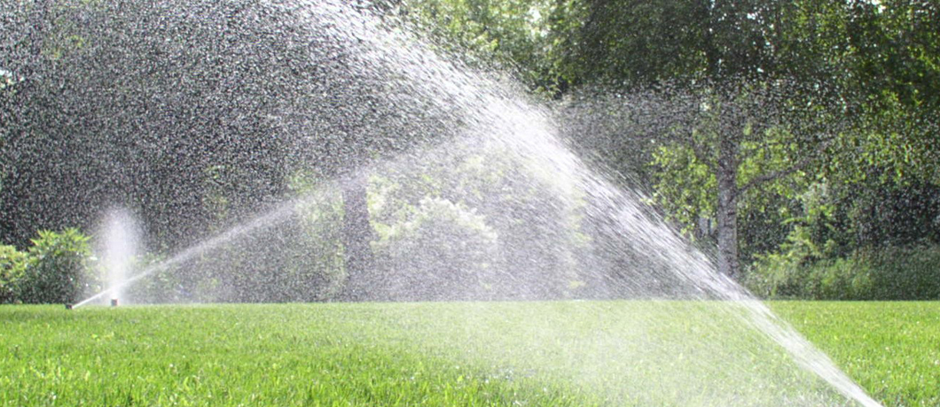

Check out our Website @ [www.pocid.org](http://www.pocid.org)

**\*Sign up for Alerts**

**\* Pay your bill**

**\* Applications/Forms**

**\* Sign up for Auto Draft**

**\* Current Projects**

**\* Agendas/Minutes**

**\* Updates**

**\* Sign up for paperless billing**

**POCID Rules and Regulations require all customers to have a customer service valve outside their meter box within 3 feet of the meter box.**

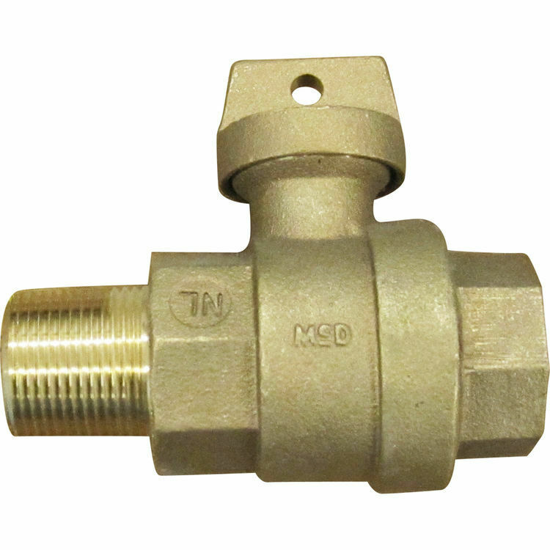



**Auto Draft Fee Waived**

Sign up for Auto Draft with your **Bank Account** for **NO FEE**!! **Please note that if you use your Credit Card there is a 3.5% fee.**

* Go to the website @ [www.pocid.org](https://l.facebook.com/l.php?u=http%3A%2F%2Fwww.pocid.org%2F%3Ffbclid%3DIwAR1RcLWgEPAebm-ZNp70EGMkdf6QCoy3I49g8QBfZVBynTieC7M20Sd3RQk&h=AT1Prcf9xoYbUFAOUcPOxbg7MUs3wGQteTOXAnPb0XsyQCf_6nsq8S0ZLhR6gLylSJ80jN-WzzwV6QRPV52KfYSAijxP7_rrHN-19yrmajQQWAYzCSAZEvriyvu3Vy86IA&__tn__=-UK-R&c%5b0%5d=AT0It4OKA8z8brbuTEnJqAzCMRBHMWLw_RM2miWdY3o9svX_12_RvDSSq26YlU-s4v5tTlpPMHOUpK6s8jjULL9C2sIy7JIpjBjH7NA7aYPhlrnfv6gpcwlxJ7UoVdNXPbOcIl0SqPXJ6ooseBqevuzRmBexfu8PNPwqE-P6XUSBxA) - select Bill Payment and log in or set up an account and then select I want to set up auto pay.

* Go online to [https://www.pocid.org/all-forms](https://www.pocid.org/all-forms?fbclid=IwAR0ESAVw63Q2_aWjDFNmgcVcvFVRqAQk7sO08dwwTp0zozGdy7qZCfYrRZc) and select POCID ACH & Credit Card Form then fill out a form and email it to [www.pocid@pocid.org](http://www.pocid@pocid.org)

* Call 844-923-2162 and pay your bill by phone 24/7

* Contact the Port O'Connor Improvement Office at 361-983-2652



