|  |  |  |  |  |
| --- | --- | --- | --- | --- |
| |  | | --- | | Monthly Newsletter  April 2024 | | |  | | --- | | Important Dates:  **POC Water Board Meetings are held on the third Thursday of each month @ 1pm**  *April 18th * May 16th * June 20th * July 18th*  **Roll off Trash Bin**  **First Saturday of each month behind the POCID Office from 8am -2pm or UNTIL FULL**  *April 6th * May 4th * June 1st \**  *July 6th* | |   **Billing**  ***Bills are mailed by the 1st***  ***of each month and are due***  ***on 20th of every month***  ***and a late fee will be assessed***  ***on the 21st unless that falls***  ***on a weekend and then it***  ***will be due the following***  ***Monday.***  **Payment Methods:**  *Credit Card*Mail*Automatic*  *Bank Draft*Automatic Credit Card Draft*In Person*Payment Drop*  *Box* Bill Pay through your*  *Financial Institute*  Contact Us  POCID  39 Denman DR  PO Box 375  Port O’Connor, Texas 77982  361-983-2652  pocid@pocid.org  <https://www.pocid.org/>  <https://www.facebook.com/POCIDofficial/>  **Vision Statement**  *POCID is a proactive organization making a positive impact on the community while implementing best management practices to promote sustainable success.*  **Mission Statement**  *To proactively and efficiently*  *manage the affairs of the District*  *for the benefit of its customers,*  *protect the health of the community, produce safe drinking water in adequate quantities, offer*  *competitive rates, assure*  *financial stability, and practice excellence in customer service.* | **“POCID”**      **“Where there is a will there is a way.”**  “Where there is a will there is a way.” There is perhaps no saying that better describes the District in the days and years following the creation election that was held in 1984. In the early years, the most pressing need was financing. There would not be any property tax income until the tax authorization elections were held and taxing approved. The first-year taxes were collected and became a source of income was 1988 at the rate of $.08 per $100.00 in property valuation. In the meantime, funding was needed to hire professionals like engineers and attorneys, to establish a District office and hire employees or contract for employees. Yet there was no funding mechanism in place. As a result, the directors had to get creative in searching for capital.  This was accomplished in several ways—loans from the county, individuals, and businesses.  Other methods utilized included IOUs for professional services rendered and the pre-pay program that was offered to residents.  Perhaps the biggest influx of cash from a single source came from Calhoun County.  The County loaned the District a substantial sum of money. This was repaid by the exchange of a portion of the property where the current community center is located to the County in exchange for debt forgiveness and a final payment of $82,050.00 via a check dated August 16, 2005. District records show evidence of loans from individuals and businesses as well along with IOUs for services rendered. There are several surviving records of these types of transactions. One such example is a letter from the District to the Port Lavaca Wave dated January 21, 1988. This correspondence informed the Wave that funds from taxes would not be available until the end of 1988 and stated: “One item we are now addressing is prior commitments. These commitments will be included in our 1988 budget and will be paid as revenues permit.” The letter goes on to request copies of statements of all monies due the Wave. Correspondence dated February 15, 1988 acknowledges a debt of $390.50 to the Wave and is marked paid with check number 115 on December 6, 1988. This appears to be a common occurrence for pre January 1, 1988 expenses incurred.  Another influx of cash was provided in the form of a loan by a company in Arkansas for the purchase of approximately 96 acres where the current District office and facilities are located. Per Teddy Hawes, who served as President at the time, the loan consisted of only interest payments until the grant was awarded. Once the grant was awarded the entire debt was retired.  The Pre-pay plan, where residents deposited $200 for free water and sewer hook ups in the future once the water and wastewater collection lines were available near their home, was also an early source of income. This proved to be a bargain for those that took advantage of the offer. At no time in the District’s history were the connection fees less than $200 for both water and sewer. In fact, they were substantially higher. For example, the water and wastewater tap fees in 2009 were:  Water Tap Fee $1,500  Water Connection Fee $100  Wastewater Tap Fee $2,000  Wastewater Connection Fee $2,000  At that time, there were still many pre-pays that had not been connected to the system resulting in a large savings if they were connected to the system in 2009 or since.  While these programs generated some operating revenue, they were not generating sufficient income to purchase the existing water system from GBRA or fund the construction of the sewer treatment plant and all the water distribution lines and wastewater collection lines that were necessary to establish a public water and wastewater collection system. To fund those types of capital projects, the District sought grants and loans from various sources including the United States Department of Agriculture.  Per individuals present in the early days, everyone was saying establishing a public water and wastewater system could not be done. Teddy Hawes recalls joining the Board of Directors and that board stating they were either going to get it done or wind down the district and there would not be a municipal utility district in Port O’Connor any more. So, the Board rolled up its sleeves and got to work with the goal of securing grant funding. One individual that was instrumental in securing grant funding for the District was Bob Kyle. The District had made inquiries to several engineering firms for engineering services but those firms had turned the board down the opportunity saying it was impossible to design and build a system due to the lack of available funding. At that point, someone from the County recommended Bob Kyle as the District’s engineer. Mr. Kyle drew up the original set of engineering plans that were submitted to various entities and organizations along with grant funding request. Mr. Kyle managed to secure a substantial amount of grant funds. However, his engineering plans were later deemed to be unusable and not capable of being approved by overseeing governmental agencies. While his plans proved untenable, his success in securing grant funds was one of the primary factors in making the District’s development feasible. Without this grant funding there would not have been a Port O’Connor Municipal Utility District possible at that time.  The District was notified in August of 2000 that it had been selected to receive a loan and grant from the United Stated Department of Agriculture. The award letter read: “Congratulations on being selected to receive a $9,163,500 loan and grant. These funds will be used to purchase and improve an existing water system and construct a vacuum wastewater collection system.” Calhoun County officials stated that was the largest grant they were aware of anyone receiving up until that time. That amount consisted of 52% in grant funding with the remainder being a loan. Those loan funds were financed with revenue bonds. Revenue bonds were selected because they were the most expedient route since they do not require voter approval and the District would not have to wait for an authorization election. However, on August 26, 2013 the District authorized the issuance of $4,700,00 in Refunding bonds to essentially refinance that original debt in tax bonds. This issuance defeased the Series 2000 and Series 2004 Port O’Connor Municipal Utility District Revenue Bonds. Those 2013 Refunding Bonds will officially be retired with the September 2024 bond payment.  The District finally had funds at its disposal and was able to purchase the existing water supply system from GBRA. That deal for $928,645.00 closed on July 20, 2000. Shortly thereafter a shrimp boil was held at the community center to celebrate the kick-off of District water services. The District was on its way; the determination of a few had found a way. |
| Growth clipart population increase, Growth population increase ...    **CONTACT US 24/7**  For an afterhours problem or emergency please call the POCID Office at 361-983-26525 and a call will be dispatched out to the on-call personnel.  Image result for aftrehours call out clip art |  |
|  | **Current Project Update**  Port O’Connor Improvement District has several projects underway in the District.  The largest group of projects is related to providing a new water supply.  The water well contractor has completed two of the five wells and has drilled test holes and completed geophysical logging on the remaining three.  The contractor for the raw water storage tanks has completed and coated the tank.  He will be painting the logo on the tank this month.  Our water line and water well facility contractor has completed the water lines and will be moving on to build the water well platforms as the driller completes his wells.  The Reverse Osmosis facility contractor is currently working on underground electrical and piping in advance of placing the slab for the proposed building.  This group of projects is partially funded by a loan from the Texas Water Development Board.  Other projects in the District include the rehabilitation of the Sanctuary water plant which was completed in March and the expansion of two sanitary sewer vacuum stations.  Vacuum Station 1B on 13th Street is substantially complete and waiting on delivery of an emergency power generator.  The contractor for Vacuum Station 2B on Monroe Street is working on excavating the vacuum station and constructing the structure.  We believe these projects will be completed by the end of 2024 and will result in a new reliable water source for Port O’Connor and a sanitary sewer collection system that will effectively transport the sewer to the treatment plant. |

**CHANGE IN NEWSLETTER DISTRIBUTION**

Due to increases in printing and postage, the Board of Directors has elected to change the newsletter from monthly distribution to a quarterly issuance to better utilize the District’s resources; therefore, the next issue will be in April of 2024.  The District will continue to post relevant information on its website and via the District’s social media outlets to keep customers up to date on District events.  As always, if you have any questions, please contact the District office.



**Irrigation Permits**

**All sprinkler systems require a permit completed and turned in to the POCID Office before installation. After installation a backflow inspection is required.**



Check out our Website @ [www.pocid.org](http://www.pocid.org)

**\*Sign up for Alerts**

**\* Pay your bill**

**\* Applications/Forms**

**\* Sign up for Auto Draft**

**\* Current Projects**

**\* Agendas/Minutes**

**\* Updates**

**\* Sign up for paperless billing**

**POCID Rules and Regulations require all customers to have a customer service valve outside their meter box within 3 feet of the meter box.**

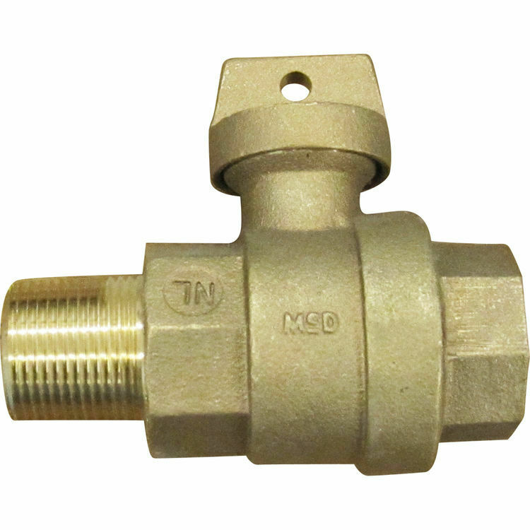



**Auto Draft Fee Waived**

Sign up for Auto Draft with your **Bank Account** for **NO FEE**!! **Please note that if you use your Credit Card there is a 3.5% fee.**

* Go to the website @ [www.pocid.org](https://l.facebook.com/l.php?u=http%3A%2F%2Fwww.pocid.org%2F%3Ffbclid%3DIwAR1RcLWgEPAebm-ZNp70EGMkdf6QCoy3I49g8QBfZVBynTieC7M20Sd3RQk&h=AT1Prcf9xoYbUFAOUcPOxbg7MUs3wGQteTOXAnPb0XsyQCf_6nsq8S0ZLhR6gLylSJ80jN-WzzwV6QRPV52KfYSAijxP7_rrHN-19yrmajQQWAYzCSAZEvriyvu3Vy86IA&__tn__=-UK-R&c%5b0%5d=AT0It4OKA8z8brbuTEnJqAzCMRBHMWLw_RM2miWdY3o9svX_12_RvDSSq26YlU-s4v5tTlpPMHOUpK6s8jjULL9C2sIy7JIpjBjH7NA7aYPhlrnfv6gpcwlxJ7UoVdNXPbOcIl0SqPXJ6ooseBqevuzRmBexfu8PNPwqE-P6XUSBxA) - select Bill Payment and log in or set up an account and then select I want to set up auto pay.

* Go online to [https://www.pocid.org/all-forms](https://www.pocid.org/all-forms?fbclid=IwAR0ESAVw63Q2_aWjDFNmgcVcvFVRqAQk7sO08dwwTp0zozGdy7qZCfYrRZc) and select POCID ACH & Credit Card Form then fill out a form and email it to [www.pocid@pocid.org](http://www.pocid@pocid.org)

* Call 844-923-2162 and pay your bill by phone 24/7

* Contact the Port O'Connor Improvement Office at 361-983-2652



