|  |  |  |  |  |  |  |  |  |  |  |  |  |  |  |  |  |  |  |  |  |  |  |  |  |  |  |  |  |  |  |  |  |  |  |  |  |  |
| --- | --- | --- | --- | --- | --- | --- | --- | --- | --- | --- | --- | --- | --- | --- | --- | --- | --- | --- | --- | --- | --- | --- | --- | --- | --- | --- | --- | --- | --- | --- | --- | --- | --- | --- | --- | --- | --- |
| |  | | --- | | Quarterly Newsletter  April 2025 | | |  | | --- | | Important Dates:  **POC Water Board Meetings are held on the third Thursday of each month @ 1pm**  *April 17th * May 15th*  *June 19th * July 17th*  **Roll off Trash Bin**  **First Saturday of each month behind the POCID Office from 8am -2pm or UNTIL FULL**  *April 5th * May 3rd*  *June 7th * July 5th* | |   **Billing**  ***Bills are mailed by the 1st***  ***of each month and are due***  ***on 20th of every month***  ***and a late fee will be assessed***  ***on the 21st unless that falls***  ***on a weekend and then it***  ***will be due the following***  ***Monday.***  **Payment Methods:**  *Credit Card*Mail*Automatic*  *Bank Draft*Automatic Credit Card Draft*In Person*Payment Drop*  *Box* Bill Pay through your*  *Financial Institute*  Contact Us  POCID  39 Denman DR  PO Box 375  Port O’Connor, Texas 77982  361-983-2652  pocid@pocid.org  <https://www.pocid.org/>  <https://www.facebook.com/POCIDofficial/>  **Vision Statement**  *POCID is a proactive organization making a positive impact on the community while implementing best management practices to promote sustainable success.*  **Mission Statement**  *To proactively and efficiently*  *manage the affairs of the District*  *for the benefit of its customers,*  *protect the health of the community, produce safe drinking water in adequate quantities, offer*  *competitive rates, assure*  *financial stability, and practice excellence in customer service.* | **“POCID”**      **Bonds**  Bonds provide an avenue to finance capital projects that spread the costs of assets that will be used for many years to all those that benefit from the assets. Issuing bonds makes financing large scale projects feasible. The decision to issue bonds is made by the District’s Board of Directors after consultation with engineers, financial advisors, attorneys, and District management. The engineers and District management offer input and identify the most pressing needs of the District and devise a recommended plan of action. The financial advisors provide information on the anticipated repayment terms, the impact on the District’s budget and tax rates, and assist in all necessary paperwork for the issuance. The attorneys review all documents and draft the offering statements and provide legal counsel throughout the process. A lot of time, consideration, and deliberation takes place prior to an issuance. The needs of the District are balanced with the financial impact on both the District, via its budget, and the public in the setting of the ad valorem tax rate.  The Board of Directors, after considering the input and recommendations from its professional consultants, makes the final decision on the amount of bonds issued and the improvements that will be financed by the proceeds. Once the Board reaches a decision, it executes a resolution authorizing the issuance of the bonds. An application outlining the intended use of the bonds is filed with the Texas Commission on Environmental Quality (“TCEQ”). After approval is given by TCEQ, the District proceeds to finalize the bond offering through the work of its professional consultants.  The District issued Series 2025 $7,390,000 unlimited tax bonds (the “2025 Bonds”) in March. After requesting competitive bids for the 2025 Bonds, the District accepted the bid resulting in the lowest net effective interest rate, which bid was tendered by SAMCO Capital Markets, Inc. for a net effective interest rate of 4.366821%, as calculated pursuant to Chapter 1204 of the Texas Government Code. The proceeds of the 2025 Bonds will be used to pay for the following wastewater improvements within the District, along with administrative costs and engineering fees associated with the issuance:   1. Wastewater Treatment Plant Improvements including rehabilitation of existing clarifiers, aeration basin, and digester components, the replacement of flowers, and improvements to diffusers, sluice gates, air lift pumps, the influent screen/splitter box, the installation of safety railing and basin cleaning; 2. Sanitary Sewer Extension Systems to expand service to growing sections of the District and to improve the system’s ability to handle infiltration; and 3. Vacuum Valve Pit Sump Replacements of approximately 350 damaged pits to reduce infiltration.   The 2025 Bonds are the second series of bonds issued out of the $40 million principal amount of unlimited tax bonds authorized by the District’s voters at the May 7, 2022 election. The first series issued was the $15,280,00 principal amount of unlimited tax bonds from 2023 leaving $17,330,000 available for future issuances of unlimited tax bonds.  Historically, the 2025 Bonds are the District’s fourth issuance of unlimited tax bonds for water and wastewater facilities and system improvements. The District has previously issued $27,280,000 principal amount of unlimited tax bonds for acquiring and constructing water and wastewater facilities in three series of bonds which were used to extend lines, build the new ground storage tank, and develop the independent water supply among other things. These earlier bond series were:   |  |  |  | | --- | --- | --- | | Series | Original Principal Amount | Outstanding Unlimited Tax Bonds | | 2013(a) | $4,700,000 | $ - | | 2018 | $6,000,000 | $4,600,000 | | 2022 | $6,000,000 | $5,705,000 | | 2023 | $15,280,000 | $15,280,000 |   As of this date, $25,585,000 remains outstanding from these prior unlimited tax bond issuances. The fourth series of unlimited tax bonds (2013(a)) consisted of $4,700,000 principal amount of unlimited tax refunding bonds. Since they were refunding bonds, they were utilized to “refinance” old debt on prior bond series to secure better repayment options. These bonds have been paid and there is no outstanding balance.  The District has also issued five series of water and sewer system revenue bonds, which are secured by and payable solely from the net revenues of the District’s water and sewer system; they are not secured by ad valorem taxes and $1,710,000 principal amount is outstanding. The revenue bonds issued by the District are as follows:   |  |  |  | | --- | --- | --- | | Series | Original Principal Amount | Outstanding Revenue Bonds | | 2000 | $2,563,000 | $ - | | 2000-A | $1,250,000 | $ - | | 2000-B | $563,000 | $ - | | 2004 | $2,325,000 | $ - | | 2015 | $2,815,000 | $1,710,000 |   A few of the projects these early revenue bonds financed were the transmission line, the wastewater treatment plant, the installation of lines—both water and wastewater—and the construction of the first ground storage tank.  At this point, it appears the next round of bonds will likely be used to construct another ground storage tank, improve the wastewater collection system, and expand the wastewater treatment plant. However, since there are no immediate plans to issue more bonds, the priorities and needs of the District could change prior to the next issuance. |
| Growth clipart population increase, Growth population increase ...  **CONTACT US 24/7**  For an after-hours problem or emergency please call the POCID Office at 361-983-2652 and a call will be dispatched to the on-call personnel.  Image result for aftrehours call out clip art | **What Comprises the District?**  The Port O’Connor Improvement District (the “District”) consists of approximately 3,299 acres of land. The amount of single-family residential homes constituting permanent residences is approximately 26%; the remaining balance of homes are second homes. The permanent population of the District is estimated at 1,747 as of December 1, 2024, based upon an estimate of 3.5 person per estimated permanent single-family residence.  Other development in the District consists of approximately 200 multi-family and commercial connections, including fishing and hunting supply stores and guide services, oil field service businesses, restaurants, fresh seafood suppliers, souvenir shops, motels, RV parks, vacation equipment rentals, a gym, lawn service businesses, liquor stores, grocery stores, convenience stores, hardware stores, marinas and marine services, real estate businesses, rental companies, condominiums, and construction and remodeling businesses.  As of January 1, 2025, the District was serving approximately 2,139 equivalent single-family connections (“ESFCs”); the District’s new well field is predicted to have sufficient volume to adequately serve 3,100 ESFCs. As of December 2024, the District was serving approximately 2,087 active wastewater connections. |
| No photo description available. | **What’s Up with the Chlorine?**  In 2000 the District purchased the GBRA water system that was supplying water to Port O’Connor. This system was installed in the 70’s and was providing water to Port O’Connor residents using the Chloramine Disinfection System. Chloramine disinfection is a combination of chlorine and ammonia in the form of Liquid Ammonia Sulfate (LAS). The LAS is used to mask the odor of the chlorine in the water. Because of the distance from the GBRA Water Treatment Plant to Port O’Connor and other extremeties of their water system, the chlorine leaving the plant at times would be as high as 4.0 mg/L or 4 parts per million as allowed by TCEQ.  On January 27, 2025 the District started producing its own water using well water from the District’s well field and the new Reverse Osmosis treatment plant. When the RO systen was put on line we had to set new parameters for our water disinfection. We are currently using chlorine without the LAS to mask the chlorine oder. The Chlorine going into our distribution system is set at a maximum of 2.5 mg/L with an average residual of 2.49mg/L. The average chlorine level for last year (GBRA water) was 3.12mg/L which is .63 mg/L higher than the current water.  We will continue to make adjustments to our disinfection but understand that we must maintain the levels required per TCEQ and the EPA. |

**Having problems flushing?**

Open or broken clean outs during rain events create problems in the system for everyone. If it’s you…Fix it! If it’s your neighbor call and let us know.

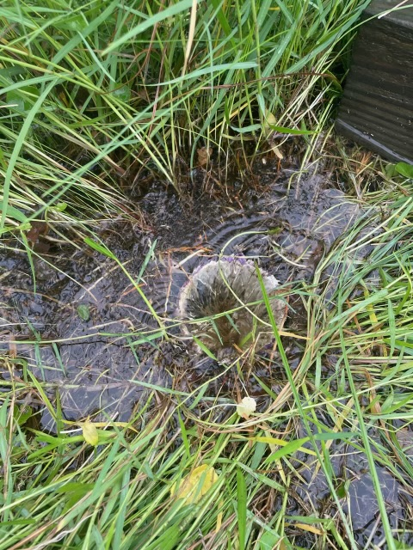

**Irrigation Permits**

**All sprinkler systems require a permit completed and turned in to the POCID Office before installation. After installation a backflow inspection is required.**



Check out our Website @ [www.pocid.org](http://www.pocid.org)

**\*Sign up for Alerts**

**\* Pay your bill**

**\* Applications/Forms**

**\* Sign up for Auto Draft**

**\* Current Projects**

**\* Agendas/Minutes**

**\* Updates**

**\* Sign up for paperless billing**

**POCID Rules and Regulations require all customers to have a customer service valve outside their meter box within 3 feet of the meter box.**

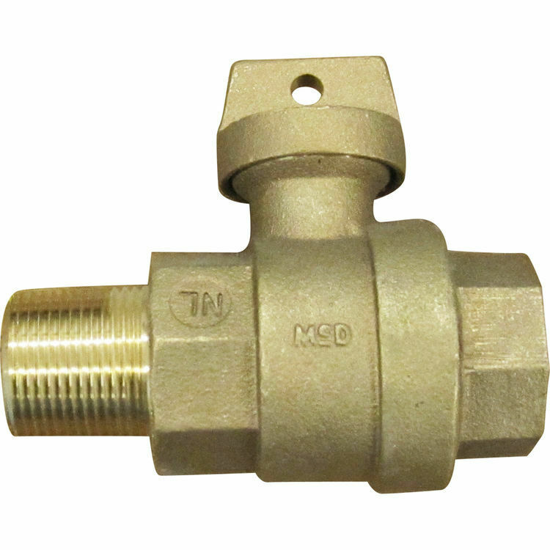



**Auto Draft Fee Waived**

Sign up for Auto Draft with your **Bank Account** for **NO FEE**!! **Please note that if you use your Credit Card there is a 3.5% fee.**

* Go to the website @ [www.pocid.org](https://l.facebook.com/l.php?u=http%3A%2F%2Fwww.pocid.org%2F%3Ffbclid%3DIwAR1RcLWgEPAebm-ZNp70EGMkdf6QCoy3I49g8QBfZVBynTieC7M20Sd3RQk&h=AT1Prcf9xoYbUFAOUcPOxbg7MUs3wGQteTOXAnPb0XsyQCf_6nsq8S0ZLhR6gLylSJ80jN-WzzwV6QRPV52KfYSAijxP7_rrHN-19yrmajQQWAYzCSAZEvriyvu3Vy86IA&__tn__=-UK-R&c%5b0%5d=AT0It4OKA8z8brbuTEnJqAzCMRBHMWLw_RM2miWdY3o9svX_12_RvDSSq26YlU-s4v5tTlpPMHOUpK6s8jjULL9C2sIy7JIpjBjH7NA7aYPhlrnfv6gpcwlxJ7UoVdNXPbOcIl0SqPXJ6ooseBqevuzRmBexfu8PNPwqE-P6XUSBxA) - select Bill Payment and log in or set up an account and then select I want to set up auto pay.

* Go online to [https://www.pocid.org/all-forms](https://www.pocid.org/all-forms?fbclid=IwAR0ESAVw63Q2_aWjDFNmgcVcvFVRqAQk7sO08dwwTp0zozGdy7qZCfYrRZc) and select POCID ACH & Credit Card Form then fill out a form and email it to [www.pocid@pocid.org](http://www.pocid@pocid.org)

* Call 844-923-2162 and pay your bill by phone 24/7

* Contact the Port O'Connor Improvement Office at 361-983-2652



