|  |  |  |  |  |
| --- | --- | --- | --- | --- |
| |  | | --- | | Quarterly Newsletter  September 2025 | | |  | | --- | | Important Dates:  **POC Water Board Meetings are held on the third Thursday of each month @ 1pm**  *September 18th * October 16th*  *November 20th * December 18th*  **Roll off Trash Bin**  **First Saturday of each month behind the POCID Office from 8am -2pm or UNTIL FULL**  *September 6th * October 4th*  *November 1st * December 6th* | |   **Billing**  ***Bills are mailed by the 1st***  ***of each month and are due***  ***on 20th of every month***  ***and a late fee will be assessed***  ***on the 21st unless that falls***  ***on a weekend and then it***  ***will be due the following***  ***Monday.***  **Payment Methods:**  *Credit Card*Mail*Automatic*  *Bank Draft*Automatic Credit Card Draft*In Person*Payment Drop*  *Box* Bill Pay through your*  *Financial Institute*  Contact Us  POCID  39 Denman DR  PO Box 375  Port O’Connor, Texas 77982  361-983-2652  pocid@pocid.org  <https://www.pocid.org/>  <https://www.facebook.com/POCIDofficial/>  **Vision Statement**  *POCID is a proactive organization making a positive impact on the community while implementing best management practices to promote sustainable success.*  **Mission Statement**  *To proactively and efficiently*  *manage the affairs of the District*  *for the benefit of its customers,*  *protect the health of the community, produce safe drinking water in adequate quantities, offer*  *competitive rates, assure*  *financial stability, and practice excellence in customer service.* | **“POCID”**      **Drought Contingency Plan**  Since the District switched from primarily surface water supplied by the old GBRA plant (currently owned by Undine) to groundwater sources of water, it had to update its Drought Contingency Plan (the “Plan”). This update was because the District’s old plan was based on GBRA’s drought contingency plan, and the stage triggers were based on river levels. River levels are not applicable for a groundwater water supply source.  Under the new plan adopted at the May 2025 Board of Directors meeting, the new triggers in the Plan are implemented according to the daily average water demand. The Plan is organized in five (5) stages with each stage determining the action taken and/or the restrictions imposed. As the stages advance, the restrictions on activities increase. For enforcement purposes, any person in apparent control of the property where a violation occurs or originates shall be presumed to be the violator unless clear evidence proving otherwise is presented to the Board. If a violator is disconnected from the water distribution system, the violator will be responsible for the current applicable reconnection fee in the District’s current Rules, Regulations, and Rate Order, along with other costs incurred by the District in disconnection of the service, plus a 17.5% service fee on those costs. After being issued three (3) warning citations, a person who violates the Plan may be fined an amount up to $10,000 per violation. Each day a violation occurs constitutes a separate offense.  In Stage One—MILD Water Shortage Conditions—customers shall be requested to voluntarily conserve water and adhere to the prescribed restrictions on certain water uses as outlined in the District’s Plan when the total daily water demand equals or exceeds 382,500 gallons for five (5) consecutive days or 400,000 gallons on a single day. Voluntary use restrictions include: (a) limiting the irrigation of landscaped areas during certain designated time periods and avoiding watering during high winds; (b) scheduling with the District, at least 3 days in advance, the use of water to refill—or add to—any indoor or outdoor swimming pool, wading pool, jacuzzi-type pool by submitting a written request to the District to receive an approved date and time for the fill; and (c) voluntary actions by customers to minimize or discontinue water usage for non-essential purposes.  Stage Two is for MODERATE Water Shortage Conditions. Customers shall be required to comply with the requirements and restrictions on certain non-essential water uses when Stage One conditions are active and the total daily water demand equals or exceeds 401,626 gallons for five (5) consecutive days or 420,000 gallons on a single day. Stage Two replaces voluntary actions with mandatory actions. Under threat of disconnection of water service for violations, the following mandatory water use restrictions apply: (a) customer physical address designated times for landscape irrigation shall be implemented for hose end sprinklers and automatic irrigation systems; (b) use of water to wash any motor vehicle, motorbike, boat, trailer or other vehicle on private premises shall be restricted to designated water days and time periods; (c) advanced scheduling of filling or refilling pools shall be required and a particular date and time will be given for the process; (d) with a few exceptions, operation of any ornamental fountain or pond for aesthetic purpose shall be prohibited; (e) restrictions on fire hydrant uses for builders and the like may be curtailed; (f) use of water for golf courses shall be restricted; and (g) restaurants shall be prohibited from serving water to patrons except upon request of the patron.  Once conditions are present to constitute a SEVERE water shortage, Stage Three of the Plan will be implemented. During Stage Three all restrictions contained and implemented in Stage Two will remain in effect with the following modifications: (a) the use of hose-end sprinklers or permanently installed automatic sprinkler systems is prohibited at all times; (b) private washing of all motor vehicles, motorbikes, boats, trailers, etc. is prohibited and commercial enterprises will have restricted operating times; (c) the filling or refilling of any type of pool is prohibited; (d) use of water from fire hydrants for construction purposes is discontinued; (e) irrigation of golf courses from a District water supply is prohibited; and (f) the non-essential purposes definition is modified to include “failure to repair a controllable leak(s) within a five (5) day period after having been given notice directing the repair of such leak(s).”  When water shortage conditions have been deemed CRITICAL, Stage Four is implemented. In Stage Four, if violators ignore a written notice of violation, the District may disconnect water services. All requirements already implemented in Stage Three remain in effect once Stage Four restrictions are declared. During Stage Four the District may suspend approval of all applications for new, additional, expanded, or increased-in-size water service connections, installation of meters, service lines, pipeline extensions, mains or water service facilities of any kind. Additionally, the non-essential water use definition is modified to include failure to repair a controllable leak(s) within a three (3) day period after receiving notice directing the repair of the leak(s).  Stage Five is implemented when EMERGENCY Water Shortage Conditions Exist. Stage Five contains restrictions on District operations, includes the ability to disconnect customers for violations, and irrigation of all landscaped areas is absolutely prohibited by any method. |
| Growth clipart population increase, Growth population increase ...  **CONTACT US 24/7**  For an after-hours problem or emergency please call the POCID Office at 361-983-2652 and a call will be dispatched to the on-call personnel.  Image result for aftrehours call out clip art | Dear Resident,  In an effort to keep your community clean and free of debris we need your help with how and where you place your garbage when needed. As your solid waste service provider, we have been asked by the Port O’Connor Improvement District to inform residents as to where and how waste should be handled.   * Republic Services (RS) will provide curbside collection of Residential trash placed in your 95-gallon cart provided by RS to each Residential unit one (1) time per week. * **Carts shall be placed at the curbside by 7:00 a.m.** on Tuesday/Wednesday each week depending on your service day. Please ensure the cart is on a flat surface. * The District has the service map that will identify which day of service you have. * **RS will collect all contents within the 95-gallon Cart(s) and up to one (1) personal container’s content with bagged garbage or yard waste. The personal container must not exceed 35 gallons in size.** * Any additional outside bags, boxes, and/or bundles outside your cart and the one (1) additional personal container will not be collected.   **(Palm trimmings cannot be placed on the ground)** * Please bag your food waste, or any waste that may be deemed unsanitary or unpleasant out of respect for your neighbors, and our drivers. **(Fish cleaning remains should be discarded in the proper containers near the cleaning stations on the bay)** * Please place **all rubbish** such as grass clippings, weeds, leaves, mulch, small trees, shrubs, limbs, waste wood, wood products, dead trees, branches, palms, or other similar items – in your cart for pickup on your scheduled day. The lid must be able to close. * If you need an additional Cart for a fee you can contact our customer service department to order one and we will bill you each month. Each Cart will still be collected once per week on your service day. * A community clean-up will be provided every other month where you may take bulky waste and brush on your own at no charge. The District will post dates in the local paper. * Hazardous waste such as insecticides, motor oil, paint, etc., and construction debris will not be permitted in the carts or outside for curbside collection. * If your cart becomes damaged (wheel, lid, body) please contact the District to request a repair/replacement. (Please expect a one week delay)   We value your business and thank you in advance for your cooperation and understanding in this matter. If you have any questions please contact our Customer Service Department at the number below, or the Improvement District at: 361-938-2652  Sincerely,  **Customer Service**  **361-698-5000** |
|  | **Water and Wastewater Usage—the Changing Demand and Supply of High Use Weekends**  You may have heard District representatives state the system has to be designed to meet the days of highest usage, even if that is only a handful of days out of the year.  When the population swells, so do the demands on the District’s water supply system and wastewater treatment plant. This past Fourth of July weekend illustrates this very well.  During the Fourth of July weekend, 3,429,000 gallons of water were pumped into the District’s water distribution system to meet the public consumption demands. Almost 3.5 million gallons of water were consumed over the course of the weekend. On the flip side, 1,794,000 gallons of wastewater, almost 2 million gallons, were received by the wastewater treatment plant for treatment.  This was significantly more than usual. The average water usage for a weekend in June was 1,549,000 gallons of water and the average wastewater treatment plant input was 904,000 gallons. As you would expect, winter numbers look much different. In February, for instance, the average water demand on a weekend was 921,000 gallons of water and 480,000 gallons of wastewater were treated during that same time through the plant.  While the current capacity may be sufficient to support the general summer population 90% of the time, the system may need expansion so it can handle the busy weekends that occasionally occur. The District recently addressed—and is still working on completing—the water supply side of the equation, but the wastewater treatment plant expansion and improvements to the wastewater collection system will need to be addressed in the not-too-distant future. The District is currently undergoing an aggressive pit replacement program to combat infiltration which puts even more pressure on the system.  By planning for the future, continuing to improve and maintain the water supply system and wastewater collection system, and expanding production and treatment capabilities the District will be prepared to handle increased demands for water and wastewater collection and treatment even on the handful of days of year when the demand is the greatest. |

**Having problems flushing?**

Open or broken clean outs during rain events create problems in the system for everyone. If it’s you…Fix it! If it’s your neighbor call and let us know.

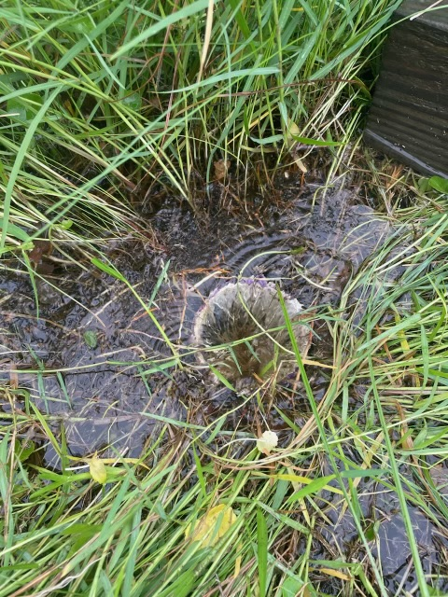

**Irrigation Permits**

**All sprinkler systems require a permit completed and turned in to the POCID Office before installation. After installation a backflow inspection is required.**

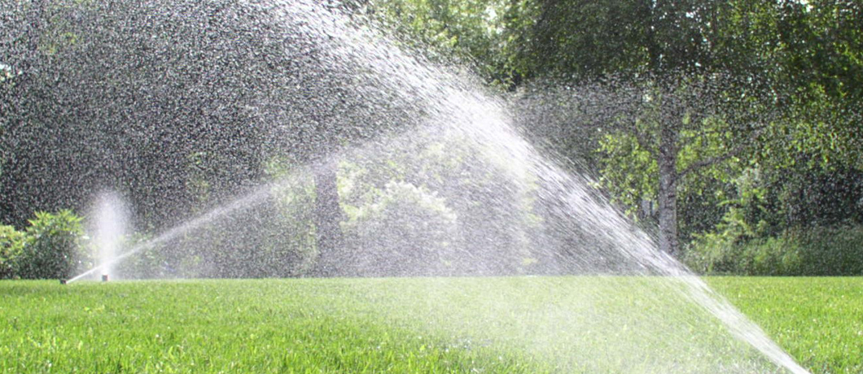

Check out our Website @ [www.pocid.org](http://www.pocid.org)

**\*Sign up for Alerts**

**\* Pay your bill**

**\* Applications/Forms**

**\* Sign up for Auto Draft**

**\* Current Projects**

**\* Agendas/Minutes**

**\* Updates**

**\* Sign up for paperless billing**

**POCID Rules and Regulations require all customers to have a customer service valve outside their meter box within 3 feet of the meter box.**

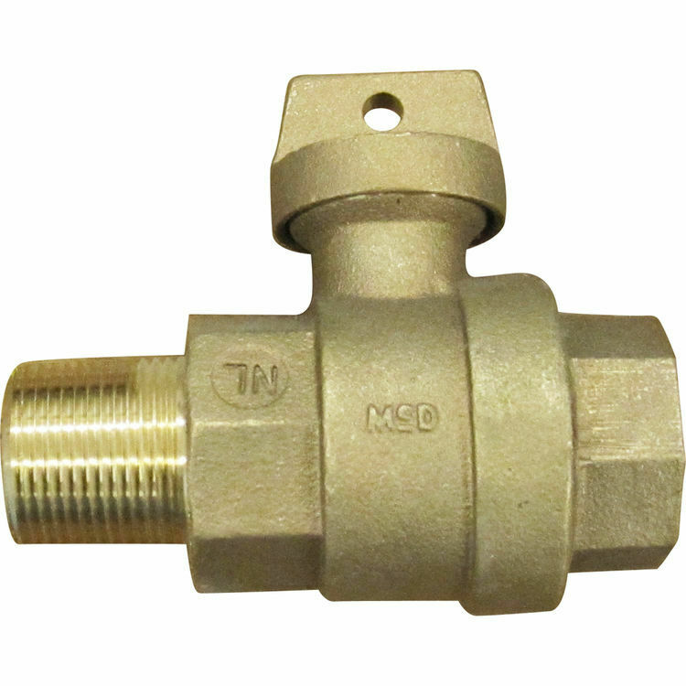



**Auto Draft Fee Waived**

Sign up for Auto Draft with your **Bank Account** for **NO FEE**!! **Please note that if you use your Credit Card there is a 3.5% fee.**

* Go to the website @ [www.pocid.org](https://l.facebook.com/l.php?u=http%3A%2F%2Fwww.pocid.org%2F%3Ffbclid%3DIwAR1RcLWgEPAebm-ZNp70EGMkdf6QCoy3I49g8QBfZVBynTieC7M20Sd3RQk&h=AT1Prcf9xoYbUFAOUcPOxbg7MUs3wGQteTOXAnPb0XsyQCf_6nsq8S0ZLhR6gLylSJ80jN-WzzwV6QRPV52KfYSAijxP7_rrHN-19yrmajQQWAYzCSAZEvriyvu3Vy86IA&__tn__=-UK-R&c%5b0%5d=AT0It4OKA8z8brbuTEnJqAzCMRBHMWLw_RM2miWdY3o9svX_12_RvDSSq26YlU-s4v5tTlpPMHOUpK6s8jjULL9C2sIy7JIpjBjH7NA7aYPhlrnfv6gpcwlxJ7UoVdNXPbOcIl0SqPXJ6ooseBqevuzRmBexfu8PNPwqE-P6XUSBxA) - select Bill Payment and log in or set up an account and then select I want to set up auto pay.

* Go online to [https://www.pocid.org/all-forms](https://www.pocid.org/all-forms?fbclid=IwAR0ESAVw63Q2_aWjDFNmgcVcvFVRqAQk7sO08dwwTp0zozGdy7qZCfYrRZc) and select POCID ACH & Credit Card Form then fill out a form and email it to [www.pocid@pocid.org](http://www.pocid@pocid.org)

* Call 844-923-2162 and pay your bill by phone 24/7

* Contact the Port O'Connor Improvement Office at 361-983-2652



