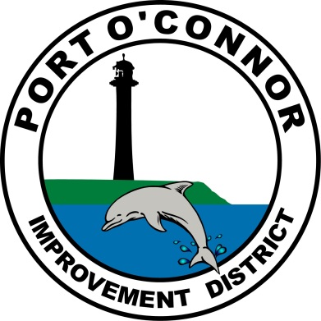
Port O’ Connor
Improvement District

P.O. Box 375/ 39 Denman Drive
Port O’ Connor, Texas 77982
Phone: (361) 983-2652
Email: pocmud@tisd.net

CUSTOMER SERVICE VALVE
DEADLINE APRIL 12, 2021

Customer Name: __________________________________ Account Number: __________________________

Service Address: _________________________________ Telephone Number: _________________________

Mailing Address: ___________________________________ E-mail: _________________________________

Payment Plan:
⃞ One Payment of $125 to be billed on monthly statement
⃞ Two equal payments of $62.50 to be billed on two consecutive monthly statements
⃞ Four equal payments of $31.25 to be billed on four consecutive monthly statements

My signature below evinces my agreement for Port O’Connor Improvement District to charge my account for the amount indicated above and constitutes my consent to be responsible for the payment amount indicated. I acknowledge that my failure to pay could lead to the discontinuance of water and sewer service to the address identified above. It also indicates my understanding that once the valve has been installed it is my responsibility to maintain, repair and replace it when needed.

_________________________________________ Date: __________________________, 2021
Customer Signature

