

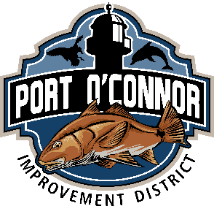

**P.O. Box 375**

**39 Denman Rd**

**Port O’Connor, TX 77982**

**361-983-2652/Fax 361-983-2235**

**Port O’Connor Improvement District**

***P.O. Box 375***

***Port O’Connor, Texas 77982***

***361-983-2652/ Fax 361-983-2235***

**Demolition of Structures Permit**

**Date: _______________**

**Meter # ______________________________________________ Account # ________________________________________**

**Customer Name: ______________________________________________ Phone: ____________________________________**

**Service Address: __________________________________________________________________________________________**

**Subdivision: _____________________________________________________ Block: ________________ Lot: ____________**

**Mailing Address: _________________________________________________________________________________________**

**Contractor: ______________________________________________________________________________________________**

**Contractor Phone: ________________________________________________________________________________________**

**Describe Project: __________________________________________________________________________________________**

**Inspected by: ___________________________________________________ Sewer Capped: ____________________________**

**________________________________________________________________________________________________________**

**BE SURE TO CALL 1-800-344-8377 BEFORE DOING ANY DIGGING.**

**I/WE ACKNOWLEDGE THAT AS A PERMIT HOLDER, I/WE ARE RESPONSIBLE TO DO DEMOLITIONS WORK ON THIS PROJECT IN ACCORDANCE WITH ALL APPLICABLE CODES, LAWS AND/OR ORDINANCES.**

**SIGNATURE OF APPLICATION: _____________________________________________________**